**Rajat Kalia |Alpha Classes**

**https://www.alphaclasses.com**

The Cook Book of Chemistry

States of Matter

**States of Matter**

**Single-Answer MCQ**

1. The density of neon will be highest at :

(1) STP (2) 0oC, 2atm

(3) 273o, 1atm (4) 273o, 2atm **[1990]**

2. The rate of diffusion of methane at a given temperature is twice that of a gas X. The molecular weight of X is

(1) 64 (2) 32

(3) 4.0 (4) 8.0 **[1990]**

3. At constant volume, for a fixed number of mole of a gas, the pressure of the gas increases with rise of temperature due to :

(1) increase in average molecular speed

(2) increase in number of moles

(3) increase in molecular attraction

(4) decrease in mean free path **[1992]**

4. A gas behaves most like an ideal gas under conditions of :

(1) high pressure and low temperature

(2) high temperature and high pressure

(3) low pressure and high temperature

(4) low pressure and low temperature **[1993]**

5. If C1, C2, C3, …. Represent the speeds of n1, n2, n3, …. Molecules, then the root mean square speed is:

(1) 

(2) 

(3) 

(4)  **[1993]**

6. The compressibility factor of a gas is defined as Z = PV/nRT. The compressibility factor of an ideal gas is :

(1) Zero (2) infinite

(3) 1 (4) -1 **[1996]**

7. A gas will approach ideal behaviour at :

(1) low T and high P (2) low T and low P

(3) high T and low P (4) high T and high P **[1999]**

8. At 100o and 1 atm, if the density of liquid water is 1.0 g cm-3 and that of water vapour is 0.0006 gcm-3, then the volume occupied by water molecules in one litre of stream at that temperature is :

(1) 6 cm3 (2) 60 cm3

(3) 0.6 cm3 (4) 0.06 cm3 **[2000]**

9. The rms speed of hydrogen is  times the rms speed of nitrogen. If T is the temperature of the gas, then :

(1)  (2) 

(3)  (4)  **[2000]**

10. The root mean square velocity of an ideal gas at constant pressure varies with density (d) as :

(1) d2 (2) d

(3)  (4)  **[2001]**

11. When the temperature is increased, surface tension of water :

(1) increases

(2) decreases

(3) remains constant

(4) shows irregular behaviour **[2002]**

12. Which of the following volume (V), temperature (T) plots represents the behaviour of one mole of an ideal gas at one atmosphere ?

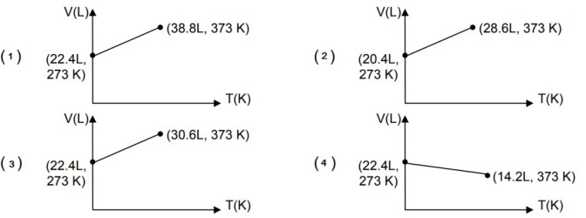 **[2002]**

13. Positive deviation from ideal behaviour takes place because of :

(1) molecular interaction between atoms and PV/nRT> 1

(2) molecular interaction between atoms and PV/nRT< 1

(3) finite size of atoms and PV/nRT> 1

(4) finite size of atoms and PV/nRT< 1 **[2003]**

14. For 1 mole of gas, the average kinetic energy is given as E. The urms of gas is :

(1)  (2) 

(3)  (4)  **[2004]**

15. The ratio of rate of diffusion of helium and methane under identical conditions of pressure and temperature is :

(1) 4 (2) 2

(3) 1 (4) 0.5 **[2005]**

16. A monoatomic ideal gas undergoes a process in which the ratio of P to V at any instant is constant and equal to unity. The molar heat capacity of the gas is :

(1) 4R/2 (2) 3R/2

(3) 5R/2 (4) zero **[2006]**

**Multiple Answer MCQ**

1. At constant volume, for a fixed number of mole of a gas, the pressure of the gas increases with rise of temperature due to :

(1) increase in average molecular speed

(2) increased rate of collisions amongst molecules

(3) increase in molecular attraction

(4) decrease in mean free path **[1992]**

2. The given graph represents the variation of Z (compressibility factor) v.s. P for three real gases A, B and C. Identify the correct statements.

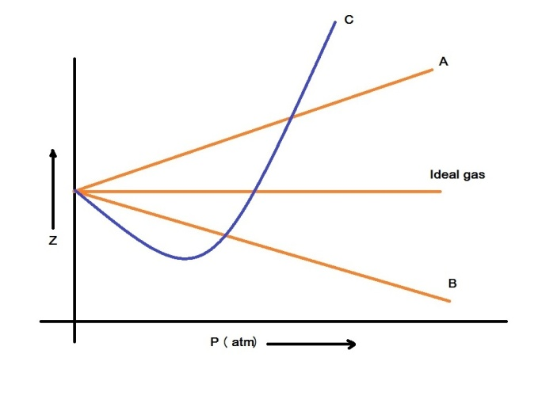

(1) For the gas A, a = 0 and its dependence on P is linear at all pressure.

(2) For the gas B, b = 0 and its dependence on P is linear at all pressure

(3) For the gas C, which is typical real gas for which a≠0, b≠0. By knowing the minima and the point of intersection with Z = 1, a and b can be calculated

(4) At high pressure, the slope is positive for all real gases. **[2008]**

3. A gas described by van der walls’ equation : **[2008]**

(1) behaves similar to an ideal gas in the limit of large molar volumes

(2) behaves similar to an ideal gas in the limit of large pressure

(3) is characterised by van der walls’ coefficients that are dependent on the identity of gas but are independent of the temperature

(4) has the pressure that is lower than the pressure exerted by the same gas behaves ideally

**Atomic Structure**

**Single-Answer MCQ**

1. A 3p-orbital has :

(1) two non-spherical nodes

(2) two spherical nodes

(3) one spherical and one non-spherical node

(4) one spherical and two non-spherical nodes **[1995]**

2. The number of nodal planes in a px-orbital is :

(1) 1 (2) 2

(3) 3 (4) zero **[2000]**

3. The electronic configuration of an element is 1s2, 2s22p6, 3s23p63d5, 4s1. This represents its :

(1) excited state (2) ground state

(3) cationic form (4) anionic form **[2000]**

## Solutions

**Solution :** A solution is a homogeneous mixture of two or more chemically non-reacting substances whose composition can be varied within certain limits.

**Mass percentage (w/w) = $\frac{Mass of the Solute}{Total mass of Solution}$**  X 100

**Volume percentage (v/v) = $\frac{Volume of the Solute}{Total Volume of Solution}$**  X 100

**Mass by Volume percentage (w/v) = $\frac{Mass of the Solute in g}{ Volume of Solution in mL}$**  X 100

**Parts per million (ppm) =**  X 106

**Mole fraction xA =**

**Molarity** M = $\frac{Number of Moles of Solute}{Volume of Solution in Litres}$

In case of ionic compounds it is called **Formality**

**Normality** N = $\frac{Number of Gram Equivalents of Solute}{Volume of Solution in Litres}$

**Molality** *m* = $\frac{Number of Moles of Solute}{Mass of solvent in kg}$

Mass % , ppm , mole fraction and molality are independent of temperature , whereas molarity is a function of temperature. This is because volume depends on temperature and the mass does not.

Q. Calculate the mole fraction of ethylene glycol (C2H6O2) in a solution containing 20% of C2H6O2 by mass.

Q. Calculate the molarity of a solution containing 5 g of NaOH in 450 mL solution. Q. Calculate molality of 2.5g of ethanoic acid (CH3COOH) in 75 g of benzene.

Q. Find the molarity and molality of a 15% solution of H2SO4 (density of H2SO4 = 1.020 g cm-1 )

Q. A sugar syrup of weight 214.2g contains 34.2g of sugar (C12H22O11). Calculate i)molal concentration II)mole fraction of sugar in the syrup.

***Solubility of a Solid in a Liquid******at any temperature is defined as the maximum amount of the solute in grams which can dissolve in 100 g of the solvent to form the saturated solution at that temperature.***

**Solubility of Solids in Liquids** depends on

i)**Nature of the solute and solvent** : Like dissolves like. Polar dissolves polar. Non polar dissolves non polar.

ii) **Temperature :**  a) for endothermic dissolution solubity increases with temperature

b) for exothermic dissolution solubility decreases with temperature

iiI) **Pressure :** No Effect.

***The solubility of any gas in a Liquid is the volume of gas in cc’s (converted to S.T.P) that can dissolve in 1 cc of the liquid to form the saturated solution******at the temperature of the experiment and under a pressure of one atmosphere.***

**Solubility of Gases in Liquids** depends on

**i) Nature of the gas and solvent :** Gases like H2S and NH3 are more soluble in polar solvents like water while gases like oxygen, nitrogen and carbon dioxide are more soluble in non polar solvents like ethyl alcohol.

II) **Temperature :** Solubility decreases with increase of temperature.

III) **Pressure :** On increasing the pressure, the solubility increases.

**Henry’s Law** : ***The partial pressure of a gas in vapour phase (p) is directly proportional to the mole fraction (x) of the gas in the solution.***

**pA = kHxA**

Applications of Henry’s Law

1) In the production of carbonated beverages.

2) In the deep sea diving.

3) In the function of lungs.

Q. The Henry’s law constant for oxygen dissolved in water is 4.34 X 104 atm at 25o C . If the partial pressure of oxygen in air is 0.2 atm under atmospheric conditions , calculate the concentration ( in moles per litre ) of dissolved oxygen in water in equilibrium with air at 25oC.

Q. If N2 gas is bubbled through water at 293 K , how many millimoles of N2 gas would dissolve in 1 litre of water. Assume that N2 exerts a partial pressure of 0.987 bar. Given that Henry’ s law constant for N2 at 293 K is 76.48 kbar.

Q. H2S , a toxic gas with rotten egg like smell , is used for the qualitative analysis. If the solubility of H2S in water at STP is 0.195m, calculate Henry’s Law Constant.

***Raoult’s Law states that for a solution of volatile liquids, the partial vapor pressure of each component in the solution is directly proportional to its mole fraction.***

**P1 = p1o x1**

**According to Dalton’s Law of partial pressures, the total pressure (ptotal) over the solution phase in the container will be the sum of the partial pressures of the components of the solution .**

**ptotal = p1o x1  + p2o x2 = p1o  + (p2o- p1o) x2**

**­pi = yi p total**

Q. Vapour pressure of chloroform (CHCl3) and dichloromethane (CH2Cl2) at 298 K are 200 mm Hg and 415 mm Hg respectively. (i) Calculate the vapour pressure of the solution prepared by mixing 25.5 g of CHCl3 and 40 g of CH2Cl2 at 298 K and , (ii) mole fractions of each component in vapour phase.

Q. The vapour pressure of pure liquids A and B are 450 and 700 mm Hg respectively, at 350 K. Find out the composition of the liquid mixture if total vapour pressure is 600 mm Hg. Also find the composition of the vapour phase.

The properties

(1) relative lowering of vapour pressure of the solvent

(2) depression of freezing point of the solvent

(3) elevation of boiling point of the solvent

(4) osmotic pressure of the solution.

***All these properties depend on the number of solute particles irrespective of their nature relative to the total number of particles present in the solution. Such properties are called colligative properties.***

**Relative lowering of vapour pressure**

$\frac{p_{1}^{0}-p_{1}}{p_{1}^{0}}$**= $\frac{n_{2}}{n_{1}{+ n}_{2}}$**

Q. The vapour pressure of pure benzene at a certain temperature is 0.850 bar. A non-volatile, non-electrolyte solid weighing 0.5 g when added to 39.0 g of benzene ( molar mass 78 g mol-1 ) . Vapour pressure of the solution ,then, is 0.845 bar. What is the molar mass of the solid substance?

Q. Vapour pressure of pure water at 298 K is 23.8 mm Hg. 50 g of urea (NH2CONH2) is dissolved in 850 g of water. Calculate the vapour pressure of water for this solution and its relative lowering.

**Elevation of boiling point**

***Kb  is called boiling point elevation constant or Molal Elevation Constant ( Ebullioscopic Constant)***

**ΔTb = Kb *m***

**Kb =**

Q. 18 g of glucose , C6H12O6, is dissolved in 1 kg of water in a saucepan. At what temperature will water boil at 1.013 bar? Kb for water is 0.52 K kg mol -1

Q. The boiling point of benzene is 353.23 K. When 1.80 g of a non-volatile solute was dissolved in 90 g of benzene, the boiling point is raised to 354.11 K . Calculate the molar mass of the solute. Kb for benzene is 2.53 K Kg mol-1

Q. Boiling point of water at 750 mm Hg is 99.63°C. How much sucrose is to be added to 500 g of water such that it boils at 100°C. Kb for water is 0.52 K kg mol -1

**Depression of freezing point**

***Kf is called Freezing Point Depression Constant or Molal Depression Constant or Cryoscopic Constant.***

**ΔTf = Kf *m***

**Kf =**

Q. 45 g of ethylene glycol C2H6O2 is mixed with 600 g of water . Calculate (a) the freezing point depression and (b) the freezing point of the solution. Kf for water is 1.86 K kg mol -1

Q. 1.00 g of a non-electrolyte solute dissolved in 50 g of benzene lowered the freezing point of benzene by 0.40 K . The freezing point depression constant of benzene is 5.12 K kg mol-1 . Find the molar mass of the solute.

Q. Calculate the mass of ascorbic acid (Vitamin C, C6H8O6) to be dissolved in 75 g of acetic acid to lower its melting point by 1.5°C. Kf = 3.9 K kg mol-1

**Osmotic pressure**

**Π = (n2/V) R T**

Q. 200 cm3 of an aqueous solution of a protein contains 1.26g of the protein. The osmotic pressure of such a solution at 300 K is found to be 2.57 x 10 -3 bar . Calculate the molar mass of the protein. (R=0.083Lbar mol-1 K-1 )

Q Calculate the osmotic pressure in pascals exerted by a solution prepared by dissolving 1.0 g of polymer of molar mass 185,000 in 450 ml of water at 37°C.

**Abnormal molar mass**

*i* = $\frac{Normal Molar Mass}{Abnormal Molar Mass}$

*i* = $\frac{Observed Colligative property}{Calculated Colligative property}$

*i* = $\frac{Total number of moles of particle after association/dissociation}{Number of moles of particles before association/dissociation}$

$\frac{p_{1}^{0}-p_{1}}{p_{1}^{0}}$**=*i $\frac{n_{2}}{n_{1}}$***

**ΔTb = *i* Kb *m***

**ΔTf = *i* Kf *m***

**Π =*i* (n2/V) R T**

Q. 2 g of benzoic acid (C6H5COOH) dissolved in 25 g of benzene shows a depression in freezing point equal to 1.62 K. Molal depression constant for benzene is 4.9 K kg mol-1 .What is the percentage association of acid if it forms dimer in solution?

Q. 0.6 mL of acetic acid (CH3COOH), Having density 1.06 g mL -1 , is dissolved in 1 Litre of water. The depression in freezing point observed for this strength of acid was 0.205oC . Calculate the van’t hoff factor and the dissociation constant of acid.

## NCERT Exercise

**2.1** Define the term solution. How many types of solutions are formed? Write briefly about each type with an example.

**2.2** Suppose a solid solution is formed between two substances, one whose particles are very large and the other whose particles are very small. What kind of solid solution is this likely to be?

**2.3** Define the following terms:

(i) Mole fraction (ii) Molality (iii) Molarity (iv) Mass percentage.

**2.4** Concentrated nitric acid used in laboratory work is 68% nitric acid by mass in aqueous solution. What should be the molarity of such a sample of the acid if the density of the solution is 1.504 g mL-1?

**2.5** A solution of glucose in water is labelled as 10% w/w, what would be the molality and mole fraction of each component in the solution? If the density of solution is 1.2 g mL–1, then what shall be the molarity of the solution?

**2.6** How many mL of 0.1 M HCl are required to react completely with 1 g mixture of Na2CO3 and NaHCO3 containing equimolar amounts of both?

**2.7** A solution is obtained by mixing 300 g of 25% solution and 400 g of 40% solution by mass. Calculate the mass percentage of the resulting solution.

**2.8** An antifreeze solution is prepared from 222.6 g of ethylene glycol (C2H6O2) and 200 g of water. Calculate the molality of the solution. If the density of the solution is 1.072 g mL–1, then what shall be the molarity of the solution?

**2.9** A sample of drinking water was found to be severely contaminated with chloroform (CHCl3) supposed to be a carcinogen. The level of contamination was 15 ppm (by mass):

(i) express this in percent by mass

(ii) determine the molality of chloroform in the water sample.

**2.10** What role does the molecular interaction play in a solution of alcohol and water?

**2.11** Why do gases always tend to be less soluble in liquids as the temperature is raised?

**2.12** State Henry’s law and mention some important applications?

**2.13** The partial pressure of ethane over a solution containing 6.56 × 10–3 g of ethane is 1 bar. If the solution contains 5.00 × 10-2 g of ethane, then what shall be the partial pressure of the gas?

**2.14** What is meant by positive and negative deviations from Raoult's law and how is the sign of ΔmixH related to positive and negative deviations from Raoult's law?

**2.15** An aqueous solution of 2% non-volatile solute exerts a pressure of 1.004 bar at the normal boiling point of the solvent. What is the molar mass of the solute?

**2.16** Heptane and octane form an ideal solution. At 373 *K*, the vapour pressures of the two liquid components are 105.2 kPa and 46.8 kPa respectively. What will be the vapour pressure of a mixture of 26.0 g of heptane and 35 g of octane?

**2.17** The vapour pressure of water is 12.3 kPa at 300 *K*. Calculate vapour pressure of 1 molal solution of a non-volatile solute in it.

**2.18** Calculate the mass of a non-volatile solute (molar mass 40 g mol–1) which should be dissolved in 114 g octane to reduce its vapour pressure to 80%.

**2.19** A solution containing 30 g of non-volatile solute exactly in 90 g of water has a vapour pressure of 2.8 kPa at 298 *K*. Further, 18 g of water is then added to the solution and the new vapour pressure becomes 2.9 kPa at 298 *K*. Calculate:

(i) molar mass of the solute (ii) vapour pressure of water at 298 *K*.

**2.20** A 5% solution (by mass) of cane sugar in water has freezing point of 271*K*. Calculate the freezing point of 5% glucose in water if freezing point of pure water is 273.15 *K*.

**2.21** Two elements A and B form compounds having formula AB2 and AB4. When dissolved in 20 g of benzene (C6H6), 1 g of AB2 lowers the freezing point by 2.3 *K* whereas 1.0 g of AB4 lowers it by 1.3 *K*. The molar depression constant for benzene is 5.1 *K* kg mol-1. Calculate atomic masses of A and B.

**2.22** At 300 K, 36 g of glucose present in a litre of its solution has an osmotic pressure of 4.98 bar. If the osmotic pressure of the solution is 1.52 bars at the same temperature, what would be its concentration?

**2.23** Suggest the most important type of intermolecular attractive interaction in the following pairs.

(i) n-hexane and n-octane

(ii) I2 and CCl4

(iii) NaClO4 and water

(iv) methanol and acetone

(v) acetonitrile (CH3CN) and acetone (C3H6O).

**2.24** Based on solute-solvent interactions, arrange the following in order of increasing solubility in n-octane and explain. Cyclohexane, KCl, CH3OH, CH3CN.

**2.25** Amongst the following compounds, identify which are insoluble, partially soluble and highly soluble in water?

(i) phenol (ii) toluene (iii) formic acid (iv) ethylene glycol (v) chloroform (vi) pentanol.

**2.26** If the density of some lake water is 1.25g mL-1 and contains 92 g of Na+ ions per kg of water, calculate the molality of Na+ ions in the lake.

**2.27** If the solubility product of CuS is 6 × 10-16, calculate the maximum molarity of CuS in aqueous solution.

**2.28** Calculate the mass percentage of aspirin (C9H8O4) in acetonitrile (CH3CN) when 6.5 g of C9H8O4 is dissolved in 450 g of CH3CN.

**2.29** Nalorphene (C19H21NO3), similar to morphine, is used to combat withdrawal symptoms in narcotic users. Dose of nalorphene generally given is 1.5 mg. Calculate the mass of 1.5X10–3 m aqueous solution required for the above dose.

**2.30** Calculate the amount of benzoic acid (C6H5COOH) required for preparing 250 mL of 0.15 M solution in methanol.

**2.31** The depression in freezing point of water observed for the same amount of acetic acid, trichloroacetic acid and trifluoroacetic acid increases in the order given above. Explain briefly.

**2.32** Calculate the depression in the freezing point of water when 10 g of CH3CH2CHClCOOH is added to 250 g of water. *K*a = 1.4 × 10-3, *K*f = 1.86 K kg mol-1.

**2.33** 19.5 g of CH2FCOOH is dissolved in 500 g of water. The depression in the freezing point of water observed is 1.0o C. Calculate the van’t Hoff factor and dissociation constant of fluoroacetic acid.

**2.34** Vapour pressure of water at 293 *K* is 17.535 mm Hg. Calculate the vapour pressure of water at 293 *K* when 25 g of glucose is dissolved in 450 g of water.

**2.35** Henry’s law constant for the molality of methane in benzene at 298 *K* is 4.27 × 105 mm Hg. Calculate the solubility of methane in benzene at 298 *K* under 760 mm Hg.

**2.36** 100 g of liquid A (molar mass 140 g mol-1) was dissolved in 1000 g of liquid B (molar mass 180 g mol-1). The vapour pressure of pure liquid B was found to be 500 torr. Calculate the vapour pressure of pure liquid A and its vapour pressure

in the solution if the total vapour pressure of the solution is 475 Torr.

**2.38** Benzene and toluene form ideal solution over the entire range of composition. The vapour pressure of pure benzene and naphthalene at 300 *K* are 50.71 mm Hg and 32.06 mm Hg respectively. Calculate the mole fraction of benzene in vapour phase if 80 g of benzene is mixed with 100 g of naphthalene.

**2.39** The air is a mixture of a number of gases. The major components are oxygen and nitrogen with approximate proportion of 20% is to 79% by volume at 298 *K*. The water is in equilibrium with air at a pressure of 10 atm. At 298 *K* if theHenry’s law constants for oxygen and nitrogen at 298 *K* are 3.30 × 107 mm and 6.51 × 107 mm respectively, calculate the composition of these gases in water.

**2.40** Determine the amount of CaCl2 (*i* = 2.47) dissolved in 2.5 litre of water such that its osmotic pressure is 0.75 atm at 27° C.

**2.41** Determine the osmotic pressure of a solution prepared by dissolving 25 mg of K2SO4 in 2 litre of water at 25° C, assuming that it is completely dissociated.

# Assignment

Problem 1. Calculate the osmotic pressure at 17°C of an aqueous solution containing 1.75 g of sucrose per 150 mL solution. [IITR 1985]

Problem 2. At 27oC*,* 36 g of glucose per litre has an O.P. of 4.92 atm. If the osmotic pressure of solution is 1.5 atm at the same temperature, what should be its concentration? [IITR 1985]

Problem 3. (a) 10 g of a certain non-volatile solute were dissolved in 100 g water at 20°C. The vapour

pressure was lowered from 17.3555 mm to 17.2350 mm, calculate m. wt. of solute.

(b) The vapour pressure of pure water at 25°C is 23.62 mm. What will be the vapour pressure of a solution of 1.5 g of urea in 50 g of water? [IITR 2001]

Problem 4. The vapour pressure of pure benzene at a certain temperature is 640 mm of Hg. A non-volatile non-electrolyte solid weighing 2.175 g is added 39.0 g of benzene. The vapour pressure of

the solution is 600 mm of Hg. What is the molecular weight of solid substance. [IIT 1990]

Problem 5. The vapour pressure of an aqueous solution of glucose is 750 mm of Hg at 373 K. Calculate

molality and mole fraction of solute. [lIT 1989]

Problem 6. The molar volume of liquid benzene (density = 0.877 g mL-1) increases by a factor of 2750 as it vaporises at 20°C and that of liquid toluene (density 0.867 g mL-1) increases by a factor of 7720 at 20°C. A solution of benzene and toluene at 20°C has a vapour pressure of 46.0 torr. Find the mole fraction of benzene in the vapour above the solution [IIT 1996]

Problem 7. A very small amount of a non-volatile solute (that does not dissociate) is dissolved in 56.8 cm3 of benzene (density 0.889 g cm-3). At room temperature, vapour pressure of this solution is 98.88 mm Hg while that of benzene is 100 mm Hg. Find the molality of this solution. If the freezing temperature of this solution is 0.73 degree lower than that of benzene, what is the value of molal freezing point depression constant of benzene? [lIT May 1997]

Problem 8. The vapour pressure of two miscible liquids *(A)* and *(B)* are 300 and 500 mm of Hg respectively. In a flask 10 mole of *(A)* is mixed with 12 mole of *(B).* However, as soon as *(B)* is added, *(A)* starts polymerising into a completely insoluble solid. The polymerization follows first-order kinetics. After 100 minute, 0.525 mole of a solute is dissolved which arrests the polymerisation completely. The final vapour pressure of the solution is 400 mm of Hg. Estimate the rate constant of the polymerisation reaction. Assume negligible volume change on mixing and polymerisation and ideal behaviour for the final solution. [IIT 2001]

Problem 9. 1.4 g of acetone dissolved in 100 g of benzene gave a solution which freezes at 277.12 K. Pure benzene freezes at 278.4 K. 2.8 g of a solid *(A)* dissolved in 100 g of benzene gave a solution which froze at 277.76 K. Calculate the molecular weight of *(A).* [IITR 2000]

Problem 10. The molal freezing point constant of C6H6 is 4.90 and its melting point is 5.51oC. A solution of 0.816 g of a compound *A* dissolved in 7.5 g of benzene freezes at 1.59°C. Calculate molecular weight of compound *A.* [IITR 1989]

Problem11. A solution of 0.643 g of an organic compound in 50 mL of benzene (density 0.879 g/mL) lowered its freezing point from 5.51 °C to 5.03°C. Calculate the molecular weight of solid. *Kf* for benzene is 5.12 K mol-1 kg. [lIT 1992]

Problem 12. A solution of a non-volatile solute in water freezes at - 0.30°C. The vapour pressure of pure water at 298 K is 23.51 mm Hg and Kf for water is 1.86 degree/molal. Calculate the vapour pressure of this solution at 298 K. [lIT 1998]

Problem 13. To 500 cm3 of water, 3.0 x 10-3 kg of acetic acid is added. If 23% of acetic acid is dissociated, what will be the depression in freezing point? *Kf* and density of water are 1.86 K kg mol-1 and 0.997 gcm-3 respectively. [lIT 2000]

Problem14. The degree of dissociation of Ca(NO3)2 in a dilute aqueous solution containing 7 g of salt

Per 100 g of water at 100°C is 70%. Calculate the vapour pressure of solution. [lIT 1991]

Problem 15**.** 1.22 g of benzoic acid is dissolved in acetone and benzene separately. Boiling point of

mixture with acetone increase by 0.17oCand boiling point of mixture with benzene increases by 0.13°C. .

*Kb* (acetone) =1.7 K kg mol-1, Mass of acetone =100 g ;

*Kb* (benzene) =2.6 K kg mol ; Mass of benzene =100 g.

Find molecular weight of benzoic acid in acetone and in benzene solution. Justify your answer with structure. [lIT 2004]

Problem 16**.** 75.2 g of C6H5OH (phenol) is dissolved in 1 kg of solvent of *Kf=* 14 K molality-1. If depression in freezing point is 7K, Calculate % of phenol that dimerises. [lIT 2006]

# Objective

1. Freezing point of an aqueous solution is-0.186°C. Elevation of boiling point of the same solution is……………. If *Kb* = 0.512 K molality-1 and *Kf =* 1.86 K molality-1:

(a) 0.186 °C (b) 0.0512 °C (c) 0.092 °C (d) 0.237 °C

2. In mixture *A* and *B,* components show –ve deviations as:

(a) ΔVmix is +ve (b) *A-B* interaction is weaker than *A-A* and *B-B* interaction.

(c) Hmix is + ve (d) *A-B* interaction is stronger than *A-A* and *B-B* interaction.

3. If liquid *A* and *B* form ideal solution, than:

(a) ΔGmix = 0 (b) Δ Hmixing = 0 (c) ΔGmix = 0, ΔSmix = 0 (d) ΔSmix = 0

4. In a 0.2 molal aqueous solution of weak acid HX (the degree of dissociation 0.3) the freezing point is

(given *Kf =* 1.85 K molality-1):

(a) -0.26°C (b) +48°C (c) -0.48°C (d) -0.36°C

5. A pressure cooker reduces cooking time for food because:

(a) the higher pressure inside the cooker crushes the food material

(b) cooking involves chemical changes helped by rise in temperature

(c) heat is more evenly distributed in the cooking space

(d) boiling point of water involved in cooking increases

6. The elevation in boiling point of a solution of 13.44 g of CuCl2 (molecular weight = 134.4, *Kb* = 0.52 K molality-1) in 1kg water using the following information will be

(a) 0.16 (b) 0.05

(c) 0.1 (d) 0.2

7. Which aqueous solution exhibits highest boiling point:

(a) *0.015M* glucose (b) 0.01*M* KNO3 (c) *0.015M* urea (d) 0.01*M* Na2SO4

8. Which liquid pair shows a positive deviation from Raoult's law:

(a) Acetone –chloroform (b) Benzene-methanol

(c) Water-nitric acid (d) Water-hydrochloric acid

9. Which statement is false:

(a) Two sucrose solutions of same molality prepared in different solvents have same Δ*Tf*

(b) Osmotic pressure, π = *MRT*

(c) Osmotic pressure for 0.01*M* aqueous solution: BaCl2 > KCl > CH3COOH > Sucrose

(d) The vapour pressure of a component over a solution is proportional to its mole fraction

10. If α is the degree of dissociation of Na2SO4 - the van't Hoff factor (i) used for calculating molecular mass is :

(a) 1+ α (b) 1- α (c) 1 + 2 α (d) 1 - 2 α

11. Benzene and toluene form nearly ideal solutions. At 20°C, the vapour pressure of benzene is 75 torr and that of toluene is 22 torr. The partial vapour pressure of benzene at 20°C for a solution containing 78 g benzene and 46 g toluene in torr is:

(a) 50 (b) 25 (c) 375

(d) 53.5

12**.** Equimolar solutions of two non-electrolytes in the same solvent have:

(a) Same b.pt. but different f.pt.

(b) Same f.pt. but different b.pt.

(c) Same b.pt. and same f.pt.

(d) Different b.pt. and different f.pt.

13**.** 18 g glucose (C6H12O6) is added to 178.2 g water. The vapour pressure of water for this aqueous solution at 100°C is:

(a) 759 torr (b) 7.60 torr (c) 76.0 torr (d) 752.40 torr

14**.** Equal masses of methane and oxygen are mixed in an empty container at 25°C. The fraction of the total pressure exerted by oxygen is:

(a) 2/3 (b)1/3 x 273/298 (c)1/3 (d)1/2

15**.** A 5.25% solution of a substance is isotonic with a 1.5% solution of urea (molar mass = 60 g mol-1) in the same solvent. If the densities of both the solutions are assumed to be equal to 1.0 g cm-3, molar mass of the substance will be :

(a) 90.0 g mol-1 (b) 115.0 g mol-1 (c) 105.0 g mol-1 (d) 210.0 g mol-1

16.A mixture of ethyl alcohol and propyl alcohol has a vapour pressure of 290 mm at 300 K. The vapour pressure of propyl alcohol is 200 mm. If the mole fraction of ethyl alcohol is 0.6, its vapour pressure (in mm) at the same temperature will be :

(a) 350 (b) 300 (c) 700

(d) 360

17.During depression of freezing point in a solution, the following are in equilibrium:

(a) liquid solvent, solid solvent (b) liquid solvent, solid solute

(c) liquid solute, solid solute (d) liquid solute, solid solvent

18.A 0.004*M* solution of Na2SO4 is isotonic with a 0.0*1M* solution of glucose at same temperature. The apparent degree of dissociation of Na2SO4 is:

(a) 25% (b) 50% (c) 75% \

(d) 85%

19.When 20 g of naphthoic acid (C11H8O2) is dissolved in 50g of benzene *(Kf =* 1.72 K kg mol-1), a freezing point depression of 2 K is observed. The van't Haff factor *(i)* is:

(a) 0.5 (b) 1.0 (c) 2.0

(d) 3.0

Solutions Test ( IIT)

Q. Vapour pressure of chloroform (CHCl3) and dichloromethane (CH2Cl2) at 298 K are 200 mm Hg and 415 mm Hg respectively. (i) Calculate the vapour pressure of the solution prepared by mixing 25.5 g of CHCl3 and 40 g of CH2Cl2 at 298 K and , (ii) mole fractions of each component in vapour phase.

20 Marks

Q. The vapour pressure of pure benzene at a certain temperature is 0.850 bar. A non-volatile, non-electrolyte solid weighing 0.5 g when added to 39.0 g of benzene ( molar mass 78 g mol-1 ) . Vapour pressure of the solution ,then, is 0.845 bar. What is the molar mass of the solid substance?

20 Marks

Q. The boiling point of benzene is 353.23 K. When 1.80 g of a non-volatile solute was dissolved in 90 g of benzene, the boiling point is raised to 354.11 K . Calculate the molar mass of the solute. Kb for benzene is 2.53 K Kg mol-1 20 Marks

Q Calculate the osmotic pressure in pascals exerted by a solution prepared by dissolving 1.0 g of polymer of molar mass 185,000 in 450 ml of water at 37°C. 20 Marks

Q. 2 g of benzoic acid (C6H5COOH) dissolved in 25 g of benzene shows a depression in freezing point equal to 1.62 K. Molal depression constant for benzene is 4.9 K kg mol-1 .What is the percentage association of acid if it forms dimer in solution? 20 Marks

The Solid State

# Test- Solid State(Objective)

**Note : Select the most suitable answer.**

1. Na and Mg crystallize in bcc and fcc type crystals respectively, then the number of atoms of Na and Mg present in the unit cell of their respectively crystal is:

(a) 4 and 2 (b) 9 and 14

(c) 14 and 9 (d) 2 and 4

**2.** How many unit cells are present in a cubic shaped ideal crystal of NaCl of mass 0.1g:



1. What type of crystal defect is indicated in the diagram given below:



1. Frenkel and Schottky defects
2. Schottky defect
3. Interstitial defect
4. Frenkel defect

**4.** An ionic compound has unit cell consisting of A icons at the corners of a cube and B ions on the centres of the faces of cube. The empirical formula of this compound is :



**5.** The volume of atoms present in a face centred cubic cell of a metal(r is atomic radius) is :



**6.** In a solid AB having the NaCl structure, A atoms occupy the corners of the cubic unit cell. If all the face centred atoms along one of the axis are removed, then the resultant stoichiometry of the solid is:



1. A substance crystallizes in face centred cubic (fcc) lattice in which atoms A occupy each corner of the cube and atoms A occupy each corner of the cube and atoms B occupy the centre of each face of the cube. The composition of  is:



1. In which of the following crystals alternate tetrahedral voids are occupied :



**9.** Match the column-I with column-II

**Column-I**

1. Simple cubic and face centred cubic
2. Cubic and rhombohedral
3. Cubic and tetragonal
4. Hexagonal and monoclinic

**Column-II**

1. have these cell parameters a = b = c and 
2. are two crystal system
3. have only two crystallography angles of 90°
4. belong to same crystal system

Solid State Test ( CBSE )

**GENERAL INSTRUCTIONS**

*(i) All questions are compulsory.*

*(ii) Marks for each question are indicated against each.*

*(iii) Question nos. 1 to 8 are very short answer questions ,carrying 1 mark each. Answer these in one word or*

*about one sentence each.*

*(iv) Question nos. 9 to 18 are short answer questions, carrying 2 marks each. Answer these in about 30 words each.*

*(v) Question nos. 19 to 27 are short answer questions, carrying 3 marks each. Answer these in about 40 words each.*

*(vi) Question nos. 28 to 30 are long answer questions, carrying 5 marks each. Answer these in about 70 words each.*

*(vii) Use Log Tables, if necessary. Use of calculators is not permitted.*

Q. 1. Name one solid which has both Schottky and Frenkel defects. 1 Marks

Q. 2. Arrange the following according to their packing fractions: 1 Marks

Simple cubic, face-centred cubic, body centred cubic

Q. 3. Why is Common salt sometimes yellow instead of being pure white? 1 Marks

Q. 4. Why is Frenkel defect not found in pure alkali metal halides? 1 Marks

Q. 5. A solid is hard, electrical insulator in the solid as well as molten state and melts at extremely high temperature. What type of solid is it ? 1 Marks

Q.6. A group 14 element is to be converted into n-type semiconductor by doping it with a suitable impurity. To which group should this impurity belong? 1 Marks

Q. 7. How does quartz glass differ from quartz? 1 Marks

Q. 8. A metallic element crystallizes into a lattice containing a sequence of layers of ABABAB Any packing of spheres leaves out voids in the lattice. What percentage by volume of this lattice is empty space? 1 Marks

Q.9. Why is glass considered as a supercooled liquid? 2 Marks

Q.10. Comment on the electrical conductivity of metals and semiconductors with increase of temperature. 2 Marks

Q.1 1. Distinguish between hexagonal and monoclinic unit cells. 2 Marks

Q.12. What type of defect can arise when a solid is heated? Which physical property is affected by it and in what

way? 2 Marks

Q.13. Non-stoichiometric cuprous oxide, Cu20 can be prepared in the laboratory. In this oxide, copper to oxygen

ratio is slightly less than 2 : 1. Can you account for the fact that this substance is a p-type semiconductor? 2 Marks

Q.14. Gold (atomic radius = 0 ·144 nm) crystallizes in a face centered unit cell. What is the length of the side of the

cell? 2 Marks

Q.15. A compound forms hexagonal close-packed structure. What is the total number of voids in 0·5 mol of it ? How many of these are tetrahedral voids? 2 Marks

Q.16. Classify each of the following as being either a p-type or n-type semiconductor giving reason. 2 Marks

*(i)* Ge doped with In

*(ii)* B doped with Si.

Q.17. In terms of band theory, what is the difference 2 Marks

*(i)* between a conductor and an insulator.

*(ii)* between a conductor and a semiconductor?

Q.18. Niobium crystallizes in a body centered cubic structure. If density is 8·55 g cm-3, calculate atomic radius of

niobium, given that its atomic mass is 93u. 2 Marks

Q.19. An element with molar mass 2·7 x 10-2kg mol-1 forms a cubic unit cell with edge length 405 pm. If its density is 2,7 x 103 kg m-3, what is the nature of the cubic unit cell? 3 Marks

Q.20. If the radius of the octahedral void is r and the radius of the atoms in the close packing is R, derive relationsip

between rand R. 3 Marks

Q.21. Analysis shows that a metal oxide has the empirical formula of M0.96O1.00 . Calculate the percentage of M2+ and M3+ ions in this crystal. 3 Marks

Q.22. In an ionic compound, the anions (N) form cubic close type of packing while the cations (M) occupy one third

of the tetrahedral voids. Deduce the empirical formula of the compound and the coordination number of (M) ions. 3 Marks

Q.23. The mineral haematite, Fe2O3 consists of a cubic close packed array of oxide ions with Fe3+ ions occupying

interstitial positions. Predict whether the iron ions are in the octahedral or tetrahedral holes. Radius of Fe3+=0·65A and that of O2- = 1·45A. 3 Marks

Q.24. If NaCl is doped with 10-3 mol % SrCl­2 What is the concentration of cation vacancies? 3 Marks

Q.25. *(a)* 'Stability of a crystal is reflected in the magnitude of its melting point'. Comment.

*(b)* The melting points of some compounds are given below:

Water = 273 K, Ethyl alcohol = 155·7 K, Diethyl ether = 156,8 K, Methane = 90·5 K. 3 Marks

What can you say about the intermolecular forces between these molecules?

Q.26. Classify each of the following solids as ionic, metallic, molecular, network (covalent) or amorphous:

*(i)* Tetraphosphorus decoxide (P4O10)

*(ii)* Ammonium phosphate, (NH4)3PO4 *(iii)* SiC *(iv)*I2 *(v)* P4 *(vi)* Plastics *(vii)* Graphite *(viii)* Brass *(ix)* Rb

*(x)* LiBr *(xi)* Si 3 Marks

Q.27. How will you distinguish between the following pairs of terms? 3 Marks

*(iii)* Hexagonal close packing and cubic close packing

*(iii)* Crystal lattice and unit cell

*(iii)* Tetrahedral void and octahedral void.

Q.28. Account for the following: 5 Marks

*(i)* Silicon is an insulator but silicon doped with phosphorus acts as a semi-conductor.

*(ii)* Some of the glass objects recovered from ancient monuments look milky instead of being transparent.

*(iii)* FeO is non-stoichiometric with the formula Fe0.95O,

Q.29. Explain the difference between the following : 5 Marks

*(i)* Ferromagnetism and antiferromagnetism

*(ii)* n and p-type semiconductors.

Q.30. Derive the expressions for the following: 5 Marks

*(i)* Density of a cubic crystal of an element of edge 'a' and atomic mass M.

*(ii)* Packing efficiency of a body-centred cubic structure.

# Electrochemistry

**Galvanic Cells**

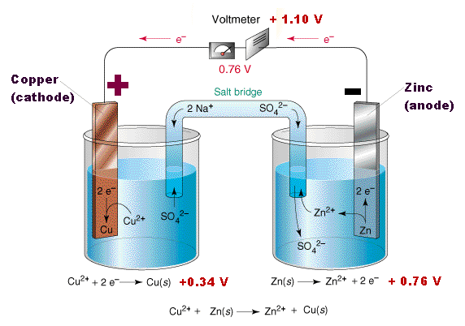

Zn(s) + Cu2+(aq) ---> Zn2+(aq) + Cu(s)

Zn(s) | Zn2+(1M) || Cu2+(1 M) | Cu(s)

Ecell = Eright - Eleft

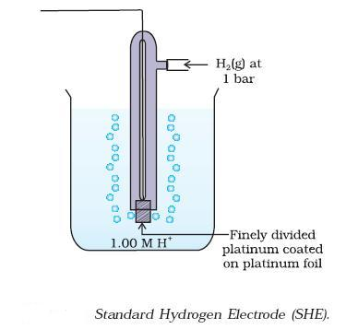

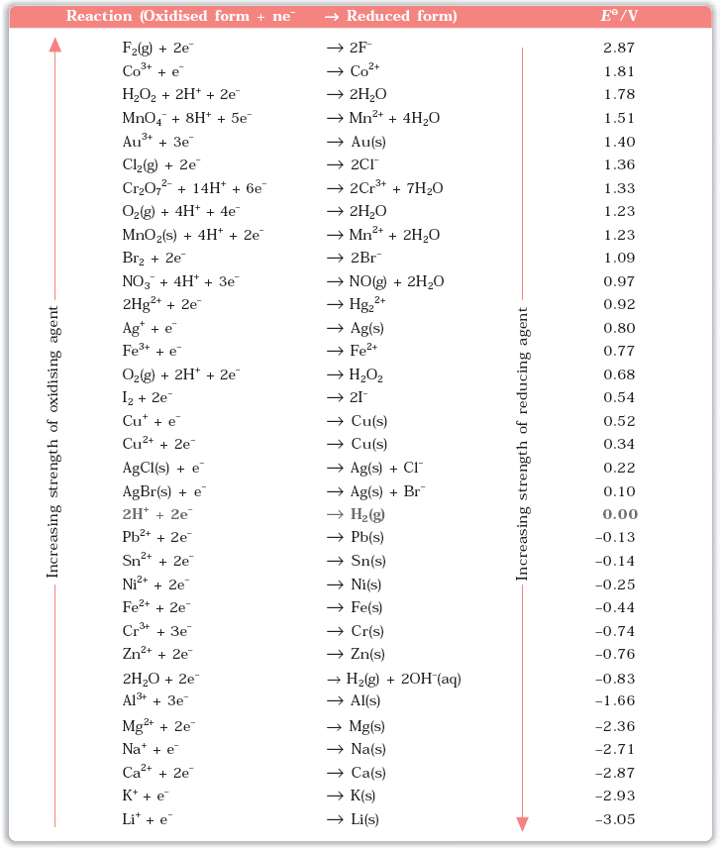

**Nernst equation**

**aA + bB ----> cC + dD**

**E cell = Eocell - ln $\frac{{[C]}^{c}{[D]}^{d}}{{[A]}^{a}{[B]}^{b}}$**

Q. Represent the cell in which the following reaction takes place **(NCERT)**

Mg(s) + 2Ag+(0.0001M) ---->Mg2+(0.130M) + 2Ag(s) Calculate its *E*(cell) if *Eθ*cell = 3.17 V.

Q. Calculate the emf of the cell in which the following reaction takes place **(NCERT)**

Ni(s) + 2Ag+ (0.002 M) ---> Ni2+ (0.160 M) + 2Ag(s)

Given that *Eθ*cell  = 1.05 V

**Equilibrium constant from Nernst Equation**

Eocell  = log Kc

Q. Calculate the equilibrium constant of the reaction: **(NCERT)**

Cu(s) + 2Ag+(aq) ---> Cu2+(aq) + 2Ag(s)

*Eθ*cell = 0.46 V

**Gibbs Energy of Reaction**

Δr Go= -nFEocell

Q. The standard electrode potential for Daniell cell is 1.1V. Calculate the standard Gibbs energy for the reaction: **(NCERT)**

Zn(s) + Cu2+(aq) --->Zn2+(aq) + Cu(s)

Q. The cell in which the following reaction occurs: **(NCERT)**

2Fe3+(aq) + 2I-(aq) ---> 2Fe2+(aq) + I2 (s) has *Eθ*cell = 0.236 V at 298 K.

Calculate the standard Gibbs energy and the equilibrium constant of the cell reaction.

Q. Calculate the potential of hydrogen electrode in contact with a solution whose pH is 10. **(NCERT)**

**Conductance of Electrolytic Solutions**

R **=** ρ $\frac{l}{A}$

R = Resistance

ρ = Resistivity

G = κ $\frac{A}{l}$

G = Conductance

κ = Conductivity

G* = $\frac{l}{A}$ = Cell Constant

Λm =

Q. Resistance of a conductivity cell filled with 0.1 mol L-1 KCl solution is 100 Ω. If the resistance of the same cell when filled with 0.02 mol L-1 KCl solution is 520 Ω, calculate the conductivity and molar conductivity of 0.02 mol L-1 KCl solution. The conductivity of 0.1 mol L-1 KCl solution is 1.29 S/m. **(NCERT)**

Q. The electrical resistance of a column of 0.05 mol L-1 NaOH solution of diameter 1 cm and length 50 cm is 5.55 × 103ohm. Calculate its resistivity, conductivity and molar conductivity. **(NCERT)**

**Kohlrausch law of independent migration of ions**

The law states that *limiting molar conductivity of an electrolyte can be represented as the sum of the individual contributions of the anion and cation of the electrolyte.*

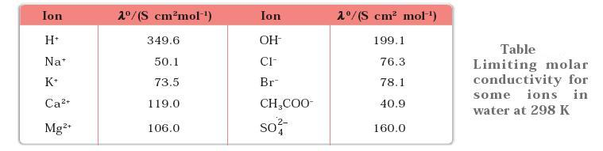

Q. Calculate *Ë*°m for CaCl2 and MgSO4 from the data given in Table **(NCERT)**

Q. *Ëm* for NaCl, HCl and NaAc are 126.4, 425.9 and 91.0 S cm2 mol-1 respectively. Calculate Λo for HAc.

**(NCERT)**

Degree of Dissociation α = $\frac{Λ_{m}}{Λ_{m}^{o}}$

Q. The conductivity of 0.001028 mol L-1 acetic acid is 4.95 × 10-5 S cm-1. Calculate its dissociation constant if *Ë*om for acetic acid is 390.5 S cm2 mol–1. **(NCERT)**

**Q.** The molar conductivity of 0.025 mol L-1 methanoic acid is 46.1 S cm2 mol-1.Calculate its degree of dissociation and dissociation constant. Given λ(H+) = 349.6 S cm2 mol-1 and λ(HCOO–) = 54.6 S cm2 mol-1 **(NCERT)**

**Faraday’s Laws of Electrolysis**

First Law : The amount of chemical reaction which occurs at any electrode during electrolysis by a current is proportional to the quantity of electricity passed through the electrolyte (solution or melt).

Second Law : The amounts of different substances liberated by the same quantity of electricity passing through the electrolytic solution are proportional to their chemical equivalent weights (Atomic Mass of Metal ÷ Number of electrons required to reduce the cation).

Q. A solution of CuSO4 is electrolysed for 10 minutes with a current of 1.5 amperes. What is the mass of copper deposited at the cathode? **(NCERT)**

**Q.** If a current of 0.5 ampere flows through a metallic wire for 2 hours, then how many electrons would flow through the wire? **(NCERT)**

**Q.** Consider the reaction: **(NCERT)**

Cr2O72-+ 14H+ + 6e– 🡪 2 Cr3+ + 8H2O

What is the quantity of electricity in coulombs needed to reduce 1 mol of Cr2O72- ?

# NCERT Exercise

1. Arrange the following metals in the order in which they displace each other from the solution of their salts. Al, Cu, Fe, Mg and Zn.

**2.** Given the standard electrode potentials, K+/K = –2.93V, Ag+/Ag = 0.80V, Hg2+/Hg = 0.79V, Mg2+/Mg = –2.37 V, Cr3+/Cr = – 0.74V

Arrange these metals in their increasing order of reducing power.

**3.** Depict the galvanic cell in which the reaction Zn(s)+2Ag+(aq) -->Zn2+(aq)+2Ag(s) takes place. Further show:

(i) Which of the electrode is negatively charged?

(ii) The carriers of the current in the cell.

(iii) Individual reaction at each electrode.

**4.** Calculate the standard cell potentials of galvanic cell in which the following reactions take place:

(i) 2Cr(s) + 3Cd2+(aq)  2Cr3+(aq) + 3Cd

(ii) Fe2+(aq) + Ag+(aq)  Fe3+(aq) + Ag(s)

Calculate the Δr*Gθ*_ and equilibrium constant of the reactions.

**5.** Write the Nernst equation and emf of the following cells at 298 K:

(i) Mg(s) | Mg2+(0.001M) || Cu2+(0.0001 M) | Cu(s)

(ii) Fe(s) | Fe2+(0.001M) || H+(1M) | H2(g)(1bar) | Pt(s)

(iii) Sn(s) | Sn2+(0.050 M) || H+(0.020 M) | H2(g) (1 bar) | Pt(s)

(iv) Pt(s) | Br2(*l*) | Br-(0.010 M) || H+(0.030 M) | H2(g) (1 bar) | Pt(s).

**6.** In the button cells widely used in watches and other devices the following reaction

takes place:

Zn(s) + Ag2O(s) + H2O(*l*) ---> Zn2+(aq) + 2Ag(s) + 2OH- (aq)

Determine Δ*rGθ*  and *Eθ* for the reaction.

**7.** Define conductivity and molar conductivity for the solution of an electrolyte.Discuss their variation with concentration.

**8.** The conductivity of 0.20 M solution of KCl at 298 K is 0.0248 S cm-1. Calculate its molar conductivity.

**9.** The resistance of a conductivity cell containing 0.001M KCl solution at 298 K is 1500 Ω. What is the cell constant if conductivity of 0.001M KCl solution at 298 K is 0.146 × 10-3 S cm-1.

**10.** The conductivity of sodium chloride at 298 K has been determined at different concentrations and the results are given below:

Concentration/M 0.001 0.010 0.020 0.050 0.100

102 × к/S m-1 1.237 11.85 23.15 55.53 106.74

Calculate *Λm* for all concentrations and draw a plot between *Λm* and *c*1/2. Find the value of *Λom*

**11.** Conductivity of 0.00241 M acetic acid is 7.896 × 10-5 S cm-1. Calculate its molar conductivity and if *Λom* for acetic acid is 390.5 S cm2 mol-1, what is its dissociation constant?

**12.** How much charge is required for the following reductions:

(i) 1 mol of Al3+ to Al.

(ii) 1 mol of Cu2+ to Cu.

(iii) 1 mol of MnO-4-  to Mn2+.

**13.** How much electricity in terms of Faraday is required to produce

(i) 20.0 g of Ca from molten CaCl2.

(ii) 40.0 g of Al from molten Al2O3.

**14.** How much electricity is required in coulomb for the oxidation of

(i) 1 mol of H2O to O2.

(ii) 1 mol of FeO to Fe2O3.

**15.** A solution of Ni(NO3)2 is electrolysed between platinum electrodes using a current of 5 amperes for 20 minutes. What mass of Ni is deposited at the cathode?

**16.** Three electrolytic cells A,B,C containing solutions of ZnSO4, AgNO3 and CuSO4, respectively are connected in series. A steady current of 1.5 amperes was passed through them until 1.45 g of silver deposited at the cathode of cell B. How long did the current flow? What mass of copper and zinc were deposited?

**17.** Using the standard electrode potentials given in **Table** predict if the reaction between the following is feasible:

(i) Fe3+(aq) and I-(aq)

(ii) Ag+ (aq) and Cu(s)

(iii) Fe3+ (aq) and Br- (aq)

(iv) Ag(s) and Fe3+ (aq)

(v) Br2 (aq) and Fe2+ (aq).

**18.** Predict the products of electrolysis in each of the following:

(i) An aqueous solution of AgNO3 with silver electrodes.

(ii) An aqueous solution of AgNO3 with platinum electrodes.

(iii) A dilute solution of H2SO4 with platinum electrodes.

(iv) An aqueous solution of CuCl2 with platinum electrodes.

## Assignment

1. Copper sulphate solution (250 ml.) was electrolysed using a platinum anode and a copper cathode. A constant current of 2 mA was passed for 16 minute. It was found that after electrolysis, the absorbance of the solution was reduced to 50% of its original value. Calculate the concentration of copper sulphate in the solution to begin with. [IIT 2000]

2. Chromium metal can be plated out from an acidic solution containing CrO3 according to following equation.

CrO3(aq.) + 6H+ + 6e 🡪 Cr(s) + 3H2O

Calculate:

I. How many gram of chromium will be plated out by 24000 coulomb?

II. How long will it take to plate out 1.5 g of Cr by using 12.5 ampere current? [IIT 1993]

3. Electrolysis of a solution of MnSO4 in aqueous sulphuric acid is a method for the preparation of MnO2 as per reaction,

Mn2+ (aq) + 2H2O 🡪 MnO2(s) + 2H+ (aq) + H2(g)

Passing a current of 27 ampere for 24 hour gives one kg of Mno2. What is the value of current efficiency? Write the reaction taking place at the cathode and at the anode. [IIT 1997]

4. In a fuel cell H2 and O2 react to produce electricity. In the process H2 gas is oxidized at the anode and O2 at cathode. If 67.2 litre of H2 at STP reacts in 15 minute, what is average current produced? If the entire current is used for electro deposition of Cu from Cu2+, how many g of Cu are deposited?

Cathode: O2 + 2H2O + 4e 🡪 4OH-

Anode: H2 + 2OH- 🡪 2H2O + 2e [IIT 1988]

5. An aqueous solution of NaCl on electrolysis gives H2(g), Cl2(g) and NaOH according to reaction:

2Cl-(aq) + 2H2O 🡪 2OH(aq) + H2(g) + Cl2(g)

A direct current of 25 ampere with a current efficiency of 62 % is passed through 20 litre of NaCl solution (20% by weight).

a) Write down the reactions taking place at the electrodes.

b) How long will it take to produce 1 kg of Cl2?

c) What will be the molarity of solution with respect to OH- ?

Assume no loss of volume due to evaporation. [IIT 1992]

6. A current of 1.7 ampere is passed through 300 ml. of 0.160 M solution of ZnSO4 for 230 sec with a current efficiency of 90%. Find the molarity of Zn2+ after the deposition of Zn. Assume the volume of the solution remains constant during electrolysis.

[IIT 1991]

7. An acidic solution of Cu2+ salt containing 0.4 g of Cu2+ is electrolysed until all the Cu is deposited. The electrolysis is continued for seven more minutes with the volume of solution kept at 100 ml. and the current at 1.2 ampere. Calculate volume of gases evolved at NTP during entire electrolysis. At. Wt. of Cu=63.6 [IIT 1989]

8. Calculate the quantity of electricity that would be required to reduce 12.3 g of nitrobenzene to aniline, if current efficiency is 50%. If the potential drop across the cell is 3.0 volt, how much energy will be consumed? [IIT 1990]

9. during the discharge of a lead storage battery, the density of sulphuric acid fell from 1.294 g ml-1 to 1.139 g ml-1 . sulphuric acid of density 1.294 g ml-1 is 39% by weight and that of density 1.139 g ml-1 is 20% by weight. The battery holds 3.5 litre of acid and the volume practically remained constant during the discharge. Calculate the no. of ampere hour for which the battery must have been used. The charging and discharging reactions are:

Pb + SO42- 🡪Pb SO4 + 2e charging

PbO2 + 4H+ + SO42- + 2e 🡪 PbSO4 + 2H2O discharging [IIT 1986]

10. How many grams of silver could be plated out on a serving tray by electrolysis of solution containing silver in +1 oxidation state for a period of 8.0 hour at a current of 8.46 ampere? What is the area of the tray if the thickness of the silver plating is 0.00254 cm? Density of silver is 10.5 g/cm3. [IIT 1997]

11. Calculate the equilibrium constant for the reaction:

Fe2+ + Ce4+ Fe3+ + Ce3+

Given: EoCe4+/Ce3+ = 1.44 V and EoFe3+/Fe2+ = 0.68V [IIT 1997]

12. The following electrochemical cell has been set up.

Pt(I) | Fe3+, Fe2+ (a=1) || Ce4+,Ce3+ (a=1) | Pt(II)

EoFe3+/Fe2+ = 0.77V and EoCe4+/Ce3+ = 1.61V

If an ammeter is connected between the two platinum electrode, predict the direction of flow of current. Will the current increase or decrease with time? [IIT 2000]

13. Calculate the equilibrium constant for the reaction, 2Fe3+ + 3I- 2Fe2+ + I-3. The standard reduction potentials in acidic conditions are 0.77 and 0.54 V respectively for Fe3+|Fe2+ and I-3|I- couples. [IIT 1998]

14. Zinc granules are added in excess to 500 ml of 1M Ni(NO3)2 solution at 25oC until the equilibrium is reached. If EoZn2+/Zn and EoNi2+/Ni are -0.75V and -0.24V respectively, find out the [Ni2+] at equilibrium.

[IIT 1991]

15. The standard reduction potential for Cu2+| Cu is + 0.34V. Calculate the reduction potential at pH = 14 for the above couple, KSP of Cu(OH)2 is 1.0 x 10-19. [IIT 1996]

16. The standard reduction potential of Cu2+|Cu and Ag+|Ag electrodes are 0.337 V and 0.799 V respectively. Construct a galvanic cell using these electrodes so that its Eosell is +ve. For what [Ag+] will the emf of cell at 25oC be zero if [Cu2+] is 0.01 M? [IIT 1990]

17. Find the solubility product of a saturated solution of Ag2CrO4 in water at 298 K if the e.m.f. of the cell Ag | Ag+ (satd. Ag2CrO4 sol.) || Ag+(0.1M) | Ag is 0.164 V at 298 K . [IIT 1998]

18. The standard reduction potential at 25oC for the reaction 2H2O + 2*e* 🡪 H2 + 2OH- is -0.8277 V. Calculate the equilibrium constant for the reaction 2H2O ⇌ H3O+ + OH- at 25oC. [IIT 1989]

19. An excess of liquid Hg was added to 10-3 acidified solution of Fe3+ ions. It was found that only 5% of the ions remained as Fe3+ at equilibrium at 25oC. Calculate Eo for 2Hg | Hg22+ at 25oC for

2Hg + 2Fe3+ ⇌ Hg22+ + 2Fe2+ and Eo Fe2+|Fe3+ = -0.77 V. [IIT 1995]

20. A cell Ag | Ag+ || Cu2+ | Cu initially contains 1 M Ag+ and 1 M Cu2+ ions . Calculate the change in the cell potential after the passage of 9.65 ampere of current for 1 hour. [IIT 1999]

## Objective

1. If Φ denotes standard, reduction potential, which is true: [AIEEE 2002]

(a) Eocell = ΦR - ΦL

(b) Eocell = ΦL + ΦR

(c) Eocell = ΦL - ΦR

(d) Eocell = - (Φ L+ Φ R)

2. Emf of a cell in terms of reduction potential of its left and right electrodes is: [AIEEE 2002]

(a) *E* = ELeft - Eright

(b) *E* = ELeft + Eright

(c) *E* = Eright - ELeft

(d) *E* = -[Eright + ELeft]

3. Conductance (Siemens, S) is directly proportional to the area of the vessel and the concentration of solution in it and is inversely proportional to the length of the vessel then, the unit of constant of proportionality is: [AIEEE 2002]

(a) S m mol-1 (b) S m2 mol-1

(c) S-2 m1 mol (d) S2 m2 mol-2

4. The emf of given cell Pt-H2 I H+ I H2-Pt is:

*P*1 *P*2[AIEEE 2002]

*a) (RF/F)* log (P1/ P2) (b) (*RF/F*) log *e (P1/P2*) c) (*RF/F*) log *e (P2/P1*) d) None of these

5. The EoM3+/*M2+* values for Cr, Mn, Fe and Co are -0.41, +1.57, +0.77 and +1.97V respectively. For which one of these metals the change in oxidation state from +2 to +3 is easiest: [AIEEE 2003]

(a) Co (b) Mn

(c) Fe (d) Cr

6. Standard reduction electrode potentials of three metals *A,* B and C are +0.5 V, -3.0 V and -1.2 V respectively. The reducing power of these metals are: [AIEEE 2003]

(a) *B>C>A* (b) *A>B>C*

*(c) C>B>A (d) A>C>B*

7. For a cell reaction involving a two electron change, the standard e.m.f., of the cell is found to be 0.295V at 25°C. The equilibrium constant of the reaction at 25°C will be: [AIEEE 2003]

(a) 1 x 10-10 (b) 29.5 x 10-2

(c) 10 (d) 1 x 1010

8. When during electrolysis of a solution of AgNO3, 9650 coulombs of charge pass through the electroplating bath, the mass of silver deposited on the cathode will be: [AIEEE 2003]

(a) 1.08 g (b) 10.8 g

(c) 21.6 g (d) 108 g

9. For the redox change; [AIEEE 2003]

Zn(s) + Cu2+ 🡪 Zn2+ + Cu(s), taking pIace in a cell Eocell is 1.10 volt. Ecell for the cell would be: 0.1M 1M

(a) 1.07 V (b) 0.82 V

(c) 2.14 V (d) 180V

10. In a hydrogen-oxygen fuel cell, combustion of hydrogen occurs to : [AIEEE 2004]

(a) remove adsorbed oxygen from electrode surfaces

(b) create potential difference between the two electrodes

(c) produce high purity water

(d) generate heat

11. Consider the following *Eo* values. *Eo Fe*3+/Fe 2+ = +0.77V, *EoSn2+/Sn* = -0.14 V, TheEocell for the reaction:

Sn(s) + 2Fe3+(aq) 🡪 2Fe2+(aq) + Sn2+(aq) is [AIEEE 2004]

(a) 0.63 V (b) 1.40 V

(c) 0.91 V (d) 1.68 V

12. The standard emf of a cell having one electron change is found to be 0.591 V at 25°C. The equilibrium constant of the reaction is: [AIEEE 2004]

(a) 1.0 x 1030 (b) 1.0 x 105

(c) 1.0 x 1010 (d) 1.0 x 101

13. In a cell that utilises the reaction;

Zn(s) + 2H+(aq.) 🡪Zn2+(aq) + H2(g)

addition of H2SO4 to cathode compartment will : [AIEEE 2004]

(a) increase the *E* and shift equilibrium to the left

(b) lower the *E* and shift equilibrium to the right

(c) increase the *E* and shift equilibrium to the right

(d) lower the *E* and shift equilibrium to the left

14. The limiting molar conductivities ∧° for NaCl, KBr and KCI are 126, 152 and 150 S cm2 mol-1 respectively. The ∧° for NaBr S cm2 mol-1 is: [AIEEE 2004]

(a) 302 (b) 176

(c) 278 (d) 128

15. The highest electrical conductivity of the following aqueous solutions is of: [AIEEE 2005]

(a) 0.1*M* acetic acid (b) 0.1*M* chloroacetic acid

(c) 0.1*M* fluoroacetic acid (d) 0.1*M* difluoroacetic acid

16. The molar conductance of acetic acid at infinite dilution if ∧° for CH3COONa, NaCI and HCl are 91.0, 126.5 and 426.2 S cm2 mol-1 respectively: [AIEEE 2005]

(a) 517.2 (b) 552.7

(c) 390.7 (d) 217.5

17. Aluminium oxide may be electrolysed at 1000°C to furnish AI metal (at. mass =27 amu). The cathode reaction is: Al3+ + *3e 🡪*  Al

How much electricity is required to prepare 5.12 kg of Al by this method: [AIEEE 2005]

(a) 5.49 x 107 coulomb (b) 1.83 x 107 coulomb

(c) 5.49 x 104 coulomb (d) 5.49 x 1010 coulomb

18.The molar conductivity ∧°NaOAc and ∧°HCl at infinite dilution in water at 25°C are 91.0, 426.2 S cm2 mol-1 respectively. To calculate ∧°HAc , the additional value required is: [AIEEE 2006]

(a) ∧°H2O (b) ∧°KCl

(c) ∧°NaOH  (d) ∧°NaCI

19. The ionic mobility of alkali metal ion in aqueous solution is maximum for: [AIEEE 2006]

(a) K+ (b) Rb+

(c) Li+ (d) Na+

20. Resistance of a conductivity cell filled with a solution of an electrolyte of concentration 0.1*M* is 100 ohm. The conductivity of this solution is 1.29 S m-1. Resistance of the same cell filled with *0.02M* of the same solution if the electrolyte is 520 ohm. The molar conductivity of *0.02M* solution of electrolyte would be :

[AIEEE 2006]

(a) 124 x 10-4 S m2 mol-1 (b) 1240 x 10-4 S m2 mol-1

(c) 1.24 x 10-4 S m2 mol-1  (d) 12.4 x 10-4 S m2 mol-1

21. At 25°C, Ag + I- 🡪 AgI + *e; Eo* = 0.152V

Ag 🡪 Ag++ *e*; *E*o =-0.80V

The log *KSP* of AgI is: (2.303RT/F = 0.059V) [AIEEE 2006]

(a) -80.12 (b) +8.612

(c) -37.83 (d) -16.13

The Organic Chemistry

## Haloalkanes

The replacement of hydrogen atom(s) in an aliphatic hydrocarbon, by halogen atom(s) results in the formation of alkyl halide (haloalkane) Haloalkanes contain halogen atom(s) attached to the *sp3* hybridised carbon atom of an alkyl group.

**Classification**

**1.) On the Basis of Number of Halogen Atoms**

These may be classified as mono, di, or polyhalogen (tri-,tetra-, etc.) compounds depending on whether they contain one, two or more halogen atoms in their structures. For example, 

**2.) Compounds Containing *sp3* C—X Bond (X= F, Cl, Br, I)**

***(a) Alkyl halides or haloalkanes (R—X)***

In alkyl halides, the halogen atom is bonded to an alkyl group (R). They form a homologous series represented by CnH2n+1X. They are further classified as primary, secondary or tertiary according to the nature of carbon to which halogen is attached.



***(b) Allylic halides***

These are the compounds in which the halogen atom is bonded to an *sp3*-hybridised carbon atom next to carbon-carbon double bond (C=C) *i.e.* to an allylic carbon.





***(c) Benzylic halides***

These are the compounds in which the halogen atom is bonded to an *sp3*-hybridised carbon atom next to an aromatic ring.



3.) **Compounds Containing *sp2* C—X Bond**

This class includes:

***(a) Vinylic halides***

These are the compounds in which the halogen atom is bonded to an *sp2*-hybridised carbon atom of a carbon-carbon double bond (C = C).



***(b) Aryl halides***

These are the compounds in which the halogen atom is bonded to the sp2-hybridised carbon atom of an aromatic ring.



**4.) Dihaloalkanes**

***(a) Vicinal dihalides***

Contain both halogens on adjacent carbon atoms. There Common name is **Alkylene Dihalides**.





Ethylene Dichloride Propylene Dibromide



Butylene dibromide

***(b) Gem dihalides***

The two halogens are present on the same carbon atom. Their common name is **Alkylidene Dihalides**.

CH3-CHBr2 Ethylidene Dibromide

CH3CH2CHBr2 n-propylidene dibromide



Isopropylidene dibromide

**5.) Trihaloalkanes**

CHCl3 Chloroform

CHBr3 Bromoform

CHI3 Iodoform

CHF3 Fluoroform

**6.) Tetrahaloalkanes**

CCl4 Carbom tetrachloride (Pyrene) {Tetrachloromethane}

**6.) Polyhaloalkanes**

C2Cl6 Hexachloroethane

Nomenclature

The common names of alkyl halides are derived by naming the alkyl group followed by the halide. Alkyl halides are named as halosubstituted hydrocarbons in the IUPAC system of nomenclature. Haloarenes are the common as well as IUPAC names of aryl halides. For dihalogen derivatives, the prefixes *o*-, *m*-, *p-* are used in common system but in IUPAC system, the numerals 1,2; 1,3 and 1,4 are used.

 

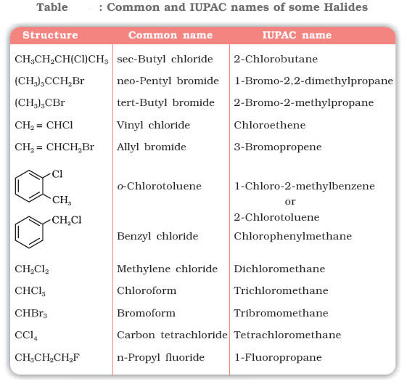

Q. Draw the structures of all the eight structural isomers that have the molecular formula C5H11Br. Name each isomer according to IUPAC system and classify them as primary, secondary or tertiary bromide. **( NCERT)**

Q. Write IUPAC names of the following: **( NCERT)**





Q **( NCERT)** .

Nature of C-X Bond

Since halogen atoms are more electronegative than carbon, the carbonhalogen bond of alkyl halide is polarised; the carbon atom bears a partial positive charge whereas the halogen atom bears a partial negative charge.

Since the size of halogen atom increases as we go down the group in the periodic table, fluorine atom is the smallest and iodine atom, the largest. Consequently the carbon-halogen bond length also increases

from C—F to C—I.



Physical Properties

Boiling Point

* Because of their greater molecular weights, haloalkanes have considerably higher boiling points than alkanes with the same number of carbons.
* For a given alkyl group, the boiling point increases with increasing atomic weight of the halogen, so that a fluoride is the lowest boiling, an Iodide the highest boiling.
* For a given halogen, the boiling point rises with increasing carbon number.The boiling point rise is 20-30 degrees for each added carbon.
* Branching involving either the alkyl groups or the halogen itself –lowers the boiling point.

Solubility

* The haloalkanes are only very slightly soluble in water. In order for a haloalkane to dissolve in water, energy is required to overcome the attractions between the haloalkane molecules and break the hydrogen bonds between water molecules. Less energy is released when new attractions are set up between the haloalkane and the water molecules as these are not as strong as the original hydrogen bonds in water. As a result, the solubility of haloalkanes in water is low. However, haloalkanes tend to dissolve in organic solvents because the new intermolecular attractions between haloalkanes and solvent molecules have much the same strength as the ones being broken in the separate haloalkane and solvent molecules.

Q. Arrange each set of compounds in order of increasing boiling points. NCERT

(i) Bromomethane, Bromoform, Chloromethane, Dibromomethane.

(ii) 1-Chloropropane, Isopropyl chloride, 1-Chlorobutane.

Methods of Preparation

1. **Grove's process**: ***Reaction of alcohol with Lucas Reagent: (conc. HCI + anhyd. ZnCl***)

This reaction is used to test pri, sec, & tert alcohol. 30 alcohols reacts instantaneously & give turbidity due to formation of insoluble chloride. 2o alcohols react to give turbidity after 5 min. whereas 1o alcohols give no turbidity as there is no reaction at room temperature.

This test is applicable only for lower alcohols which are water soluble. It is because alcohols having more than 6 carbon are almost insoluble in water hence two immiscible liquid is present before the addition of Lucas Reagent, so the presence of alkyl halide can't be detected properly.

In this process replacement "OH" group in primary and secondary alcohols with an "X” atom by means of Hydrogen chloride or bromide in presence of Zinc chloride. But for tertiary alcohol readily react with concentrated hydrochloric acid in the absence of zinc chloride. Zinc chloride is a lewis acid and consequently can co-ordinate with the alcohol



The R-O bond is weakened and so the complex readily forms a carbonium ion (SN1 mechanism). If the nature of R+ is such that it can ,undergo rearrangement the product will be mixture of isomeric alkyl chlorides.

The reaction also follows S2 mechanism when the concentration of zinc chloride is low, the reaction is still catalysed, but no rearrangement occurs.



* Pyridine and dimethyl amine also catalyse the reaction between alcohols and hydrochloric acid without rearrangement

To avoid rearrangement or to make this reaction SN2. **Tosylation** process can be used, - OTs

is a weak nucleophile & better leaving group. Due to its bulkyness it prefers SN2 reaction by

backside attack of nucleophile.





* For alkyl iodide a non oxidising acid is used along with KI [HI is not preferred as it is a good reducing agent]



Q . Why is sulphuric acid not used during the reaction of alcohols with KI? **(NCERT)**

Q. What happens when neopentyl alcohol reacts with anhydrous hydrogen bromide?



2. **Darzen’s Process.** Thionyl chloride reacts with straight-chain primary alcohols without

rearrangement in the presence or absence of pyridine the reaction proceeds via a

chloro sulphite

Mechanism



3. With **PCl5**



If R group is tertiary, It will be SN1 reaction which takes place via recamization (via carbocation formation). Rearrangement also takes place.

4. **Reaction with phosphorus Halide.**

This reaction takes place via SN2 without rearrangement and via inversion of configuration.

[Only with 3o alcohol reaction is SN1 & nucleophile can attack from either ends on carbocation

to give a racemic mixture].

3ROH + PCI3 -----> RCI + H3PO3



Phosphorus tribromide and triiodide are usually generated *in situ* (produced in the reaction mixture) by the reaction of red phosphorus with bromine and iodine respectively.

r



5. **By Free Radical Halogenation**

Detailed Mechanism (Free radical Substitution Reaction)

1. Initiation Step

It is the hemolytic cleavage of chlorine molecule to chlorine free radical by absorbing energy when Cl2 is subjected to UV light at room temperature.

2. Propagation step

a) The chlorine free radical attacks the alkane molecule , abstracts a hydrogen atom giving hydrogen chloride and alkyl free radical.

b) The alkyl free radical reacts further with a chlorine molecule forming alkyl chloride and chlorine free radical.

3. Termination Step.

In this step , the free radicals obtained during the propagation may combine to give products.

* Iodination of alkanes is slow and reversible process because of formation of strong reducing agent , hydrogen iodide , as a by- product which reduces iodoalkane back to alkane

CH4 + I2 ⇌ CH3I + HI

Thus direct iodination of alkane is not possible.

To get iododerivatives we use strong oxidizing agents like iodic acid (HIO3) ,periodic acid (HIO4) , nitric acid (HNO3) or mercuric oxide HgO which convert HI to I2 or destroy Iodide

5HI + HIO3 ----> 3 I2 + 3 H2O

2 HI + 2 HNO3 ----> I2 + 2 H2O + 2 NO2

2 HI + HgO ----> HgI2 + H2O

* Fluorination of alkanes is highly exothermic or explosive, hence it cannot be controlled under ordinary conditions. Further more , fluorination brings about extensive rupture of C-C and C-H bond leading to a mixture of fluoroproducts.

Q. Identify all the possible monochloro structural isomers expected to be formed on free radical monochlorination of (CH3)2CHCH2CH­3. **(NCERT)**

***6.) From alkenes***

(i) *Addition of hydrogen halides*: An alkene is converted to corresponding alkyl halide by reaction with hydrogen chloride, hydrogen bromide or hydrogen iodide.



Propene yields two products, however only one predominates as per Markovnikov’s rule.





Q.

NCERT

**7.) Halogen exchange**

**a) Finkelstein Reaction**

Alkyl iodides are often prepared by the reaction of alkyl chlorides/bromides with NaI in **dry acetone.**



NaCl or NaBr thus formed is precipitated in dry acetone. It facilitates the forward reaction according to Le Chatelier’s Principle.

**b) Swarts Reaction**

The synthesis of alkyl fluorides is done by heating an alkyl chloride/bromide in the presence of a metallic fluoride such as AgF, Hg2F2, CoF2 or SbF3.



Q. Write structures of different dihalogen derivatives of propane. NCERT

Q. Among the isomeric alkanes of molecular formula C5H12, identify the one that on photochemical chlorination yields NCERT

(i) A single monochloride.

(ii) Three isomeric monochlorides.

(iii) Four isomeric monochlorides.

Q .



NCERT

8.) Borodine Hundsdiecker reaction

RCOOAg + Br2 ----> RBr + CO2 + AgBr

The yield of halide is primary> secondary> tertiary

Mechanism is through free radical formation:

RCOOAg + Br2 ----> RCOOBr + AgBr



## Reactions of Haloalkanes

## (i) *Nucleophilic substitution reactions*

## 



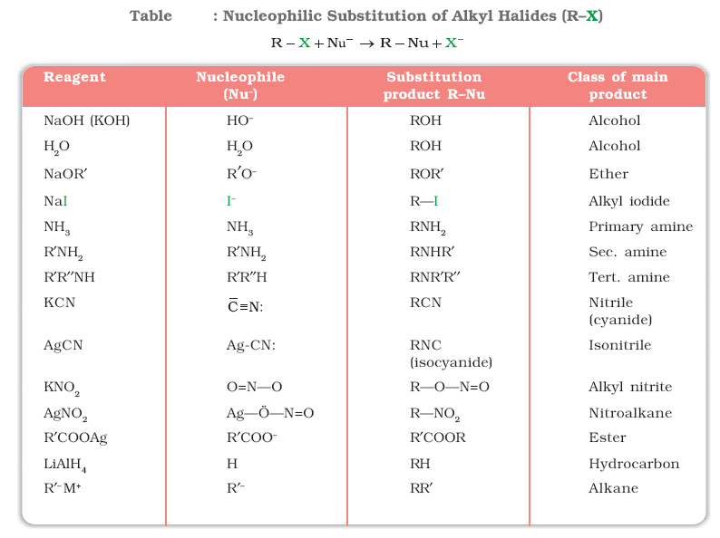

Groups like cyanides and nitrites possess two nucleophilic centres and are called ***ambident nucleophiles***. Actually cyanide group is a hybrid of two contributing structures and therefore can act as a nucleophile in two different ways [-C≡N ↔ :C=N-], *i.e.,* linking through carbon atom resulting in alkyl cyanides and through nitrogen atom leading to isocyanides. Similarly nitrite ion also represents an ambident nucleophile with two different points of linkage [–O—N=O]. The linkage through oxygen results in alkyl nitrites while through nitrogen atom, it leads to nitroalkanes.

Q. Haloalkanes react with KCN to form alkyl cyanides as main product while AgCN forms isocyanides as the chief product. Explain. **(NCERT)**

KCN is predominantly ionic and provides cyanide ions in solution.Although both carbon and nitrogen atoms are in a position to donateelectron pairs, the attack takes place mainly through carbon atom and

not through nitrogen atom since C—C bond is more stable than C—N bond. However, AgCN is mainly covalent in nature and nitrogen is freeto donate electron pair forming isocyanide as the main product.

***(a) Substitution nucleophilic bimolecular (SN2)***



The incoming nucleophile interacts with alkyl halide causing the carbonhalide bond to break while forming a new carbon-OH bond. These two processes take place simultaneously in a single step and no intermediate is formed. As the reaction progresses and the bond between the nucleophile and the carbon atom starts forming, the bond between carbon atom and leaving group weakens. As this happens, the configuration of carbon atom under attack inverts in much the same way as an umbrella is turned inside out when caught in a strong wind, while the leaving group is pushed away. This process is called as **inversion of configuration**. In the transition state, the carbon atom is simultaneously bonded to incoming nucleophile and the outgoing leaving group and such structures are unstable and cannot be isolated. This is because the carbon atom in the transition state is simultaneously bonded to five atoms and therefore is unstable. Tertiary halides are the least reactive because bulky groups hinder the approaching nucleophiles. Thus the order of reactivity followed is:

Primary halide > Secondary halide > Tertiary halide.

## *(b) Substitution nucleophilic unimolecular (SN1)*



It occurs in two steps. In step I, the polarised C—Br bond undergoes slow cleavage to produce a carbocation and a bromide ion. The carbocation thus formed is then attacked by nucleophile in step II

to complete the substitution reaction. Step I is the slowest and reversible. It involves the C–Br bond breaking for which the energy is obtained through solvation of halide ion with the proton of protic solvent. Since the rate of reaction depends upon the slowest step, the rate of reaction depends only on the concentration of alkyl halide and not on the concentration of hydroxide ion. Further, greater the stability of carbocation, greater will be its ease of formation from alkyl halide and faster will be the rate of reaction. In case of alkyl halides, 30 alkyl halides undergo SN1 reaction very fast because of the high stability of 30 carbocations.



## Allylic and benzylic halides show high reactivity towards the SN1 reaction. The carbocation thus formed gets stabilised through resonance



For a given alkyl group, the reactivity of the halide, R-X, follows the same order in both the mechanisms R–I> R–Br>R–Cl>>R–F.



Q

Q.



Q. Identify chiral and achiral molecules in each of the following pair of compounds.



In case of optically active alkyl halides, the product formed as a result of SN2 mechanism has the inverted configuration as compared to the reactant. This is because the nucleophile attaches itself on the side opposite to the one where the halogen atom is present. When (–)-2-bromooctane is allowed to react with sodium hydroxide, (+)-octan-2-ol is formed with the –OH group occupying the position opposite to what bromide had occupied.



Thus, SN2 reactions of optically active halides are accompanied by inversion of configuration.

In case of optically active alkyl halides, SN1 reactions are accompanied by racemisation. Actually the carbocation formed in the slow step being *sp2* hybridised is planar (achiral). The attack of the nucleophile may be accomplished from either side resulting in a mixture of products, one having the same configuration (the –OH attaching on the same position as halide ion) and the other having opposite configuration (the –OH attaching on the side opposite to halide ion). This may be illustrated by hydrolysis of optically active 2-bromobutane, which results in the formation of (±)-butan-2-ol.



## *2. Elimination reactions*



Saytzeff Rule

“*in dehydrohalogenation reactions, the preferred product is that alkene which has the greater number of alkyl groups attached to the doubly bonded carbon atoms*.”

Thus, 2-bromopentane gives pent-2-ene as the major product.



***3. Reaction with metals***

**Grignard Reagents**.



These reagents are obtained by the reaction of haloalkanes with magnesium metal in dry ether.

In the Grignard reagent, the carbon-magnesium bond is covalent but highly polar, with carbon pulling electrons from electropositive magnesium; the magnesium halogen bond is essentially ionic.

Grignard reagents are highly reactive and react with any source of proton to give hydrocarbons.



***Wurtz reaction***

Alkyl halides react with sodium in dry ether to give hydrocarbons containing double the number of carbon atoms present in the halide. This reaction is known as **Wurtz reaction.**



***Wurtz-Fittig reaction***

A mixture of an alkyl halide and aryl halide gives an alkylarene when treated with sodium in dry ether and is called Wurtz-Fittig reaction.



***Fittig reaction***

Aryl halides also give analogous compounds when treated with sodium in dry ether, in which two aryl groups are joined together. It is called Fittig reaction.



Q.



Q.



Q.



## Aryl Halides

**Methods of Preparation**

***a)By electrophilic substitution***

Aryl chlorides and bromides can be easily prepared by electrophilic substitution of arenes with chlorine and bromine respectively in the presence of Lewis acid catalysts like iron or iron(III) chloride. The *ortho* and *para* isomers can be easily separated due to large difference in their melting points. Reactions with iodine are reversible in nature and require the presence of an oxidising agent (HNO3, HIO4) to oxidise the HI formed during iodination.



***(b) Sandmeyer’s reaction***

When a primary aromatic amine, dissolved or suspended in cold aqueous mineral acid, is treated with sodium nitrite, a diazonium salt is formed . Mixing the solution of freshly prepared diazonium salt with cuprous chloride or cuprous bromide results in the replacement of the diazonium group by –Cl or –Br.



Replacement of the diazonium group by iodine does not require the presence of cuprous halide and is done simply by shaking the diazonium salt with potassium iodide.



**Reactions of Haloarenes**

Aryl halides are extremely less reactive towards nucleophilic substitution reactions

The presence of an electron withdrawing group (-NO2) at *ortho*- and *para*-positions increases the reactivity of haloarenes.

The effect is pronounced when (-NO2) group is introduced at *ortho* and *para*- positions. However, no effect on reactivity of haloarenes is observed by the presence of electron withdrawing group at *meta*-position. Mechanism of the reaction is as depicted:



***2. Electrophilic substitution reactions***

Haloarenes undergo the usual electrophilic reactions of the benzene ring such as halogenation, nitration, sulphonation and Friedel-Crafts reactions. Halogen atom besides being slightly deactivating is *o, p*directing; therefore, further substitution occurs at *ortho-* and *para*positions with respect to the halogen atom. The *o, p*-directing influence of halogen atom can be easily understood if we consider the resonating structures of halobenzene



Due to resonance, the electron density increases more at *ortho-* and *para*-positions than at *meta*-positions. Further, the halogen atom because of its –I effect has some tendency to withdraw electrons from the benzene ring. As a result, the ring gets somewhat deactivated as compared to benzene and hence the electrophilic substitution reactions in haloarenes occur slowly and require more drastic conditions as compared to those in benzene.





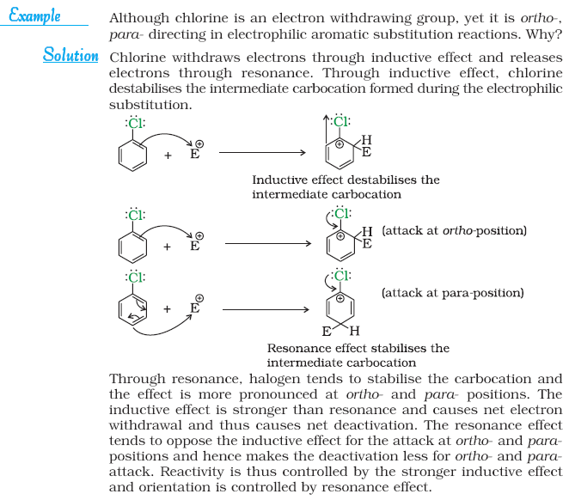

## NCERT Exercise



Q1.

Q2.



Q3.



**Q 4** Which one of the following has the highest dipole moment?

(i) CH2Cl2 (ii) CHCl3 (iii) CCl4

**Q 5** A hydrocarbon C5H10 does not react with chlorine in dark but gives a single monochloro compound C5H9Cl in bright sunlight. Identify the hydrocarbon.

**Q.6** Write the isomers of the compound having formula C4H9Br.

**Q.7** Write the equations for the preparation of 1-iodobutane from

(i) 1-butanol (ii) 1-chlorobutane (iii) but-1-ene.

**Q.8** What are ambident nucleophiles? Explain with an example.

**Q.9** Which compound in each of the following pairs will react faster in SN2 reaction

with –OH?

(i) CH3Br or CH3I (ii) (CH3)3CCl or CH3Cl

**Q.10** Predict all the alkenes that would be formed by dehydrohalogenation of the following halides with sodium ethoxide in ethanol and identify the major alkene:

(i) 1-Bromo-1-methylcyclohexane (ii) 2-Chloro-2-methylbutane

(iii) 2,2,3-Trimethyl-3-bromopentane.

**Q.11** How will you bring about the following conversions?

(i) Ethanol to but-1-yne (ii) Ethane to bromoethene (iii) Propene to

1-nitropropane (iv) Toluene to benzyl alcohol (v) Propene to propyne

(vi) Ethanol to ethyl fluoride (vii) Bromomethane to propanone (viii) But-1-ene

to but-2-ene (ix) 1-Chlorobutane to n-octane (x) Benzene to biphenyl.

**Q.12** Explain why

(i) the dipole moment of chlorobenzene is lower than that of cyclohexyl chloride?

(ii) alkyl halides, though polar, are immiscible with water?

(iii) Grignard reagents should be prepared under anhydrous conditions?

Q.1



Q.15 Write the mechanism of the following reaction:



Q 16 Arrange the compounds of each set in order of reactivity towards SN2 displacement:

(i) 2-Bromo-2-methylbutane, 1-Bromopentane, 2-Bromopentane

(ii) 1-Bromo-3-methylbutane, 2-Bromo-2-methylbutane, 3-Bromo-2-methylbutane

(iii) 1-Bromobutane, 1-Bromo-2,2-dimethylpropane, 1-Bromo-2-methylbutane,1-Bromo-3-methylbutane.

**Q.17** Out of C6H­5CH2Cl and C6H5CHClC6H5, which is more easily hydrolysed by aqueous KOH?

**Q.18** *p*-Dichlorobenzene has higher m.p. and solubility than those of *o*- and *m*-isomers.

Discuss.

**Q.19** How the following conversions can be carried out?

(i) Propene to propan-1-ol

(ii) Ethanol to but-1-yne

iii) 1-Bromopropane to 2-bromopropane

(iv) Toluene to benzyl alcohol

(v) Benzene to 4-bromonitrobenzene

(vi) Benzyl alcohol to 2-phenylethanoic acid

(vii) Ethanol to propanenitrile

(viii) Aniline to chlorobenzene

(ix) 2-Chlorobutane to 3, 4-dimethylhexane

(x) 2-Methyl-1-propene to 2-chloro-2-methylpropane

(xi) Ethyl chloride to propanoic acid

(xii) But-1-ene to n-butyliodide

(xiii) 2-Chloropropane to 1-propanol

(xiv) Isopropyl alcohol to iodoform

(xv) Chlorobenzene to *p*-nitrophenol

(xvi) 2-Bromopropane to 1-bromopropane

(xvii) Chloroethane to butane

(xviii) Benzene to diphenyl

(xix) *tert*-Butyl bromide to isobutyl bromide

(xx) Aniline to phenylisocyanide

**Q.20** The treatment of alkyl chlorides with aqueous KOH leads to the formation of alcohols but in the presence of alcoholic KOH, alkenes are major products. Explain.

**Q.21** Primary alkyl halide C4H9Br (a) reacted with alcoholic KOH to give compound (b). Compound (b) is reacted with HBr to give (c) which is an isomer of (a). When (a) is reacted with sodium metal it gives compound (d), C8H18 which is different from the compound formed when n-butyl bromide is reacted with sodium. Give the structural formula of (a) and write the equations for all the reactions.

**Q.22** What happens when

(i) n-butyl chloride is treated with alcoholic KOH,

(ii) bromobenzene is treated with Mg in the presence of dry ether,

(iii) chlorobenzene is subjected to hydrolysis,

(iv) ethyl chloride is treated with aqueous KOH,

(v) methyl bromide is treated with sodium in the presence of dry ether,

(vi) methyl chloride is treated with KCN?

## Alcohols

**Alcohols** and **phenols** are formed when a hydrogen atom in a hydrocarbon, aliphatic and aromatic respectively, is replaced by –OH group.

The subsitution of a hydrogen atom in a hydrocarbon by an alkoxy or aryloxy group (R–O/Ar–O) yields another class of compounds known as ‘**ethers**’

**Classification**

***Mono, Di, Tri or Polyhydric Compounds***

Alcohols and phenols may be classified as mono–, di–, tri- or polyhydric compounds depending on whether they contain one, two, three or many hydroxyl groups



1. *Compounds containing* C *sp* 3 −OH *bond:*

In this class of alcohols, the –OH group is attached to an sp3hybridised carbon atom of an alkyl group. They are further classified as follows:

*Primary, secondary and tertiary alcohols:* In these three types of alcohols, the –OH group is attached to primary, secondary and tertiary carbon atom.



1. *Compounds containing* C *sp* 2 −OH *bond:*

These alcohols contain —OH group bonded to a carbon-carbon double bond i.e., to a vinylic carbon or to an aryl carbon. These alcohols are also known as vinylic alcohols.



**Ethers**

Ethers are classified as **simple** or **symmetrical**, if the alkyl or aryl groups attached to the oxygen atom are the same, and **mixed** or **unsymmetrical**, if the two groups are different. Diethyl ether, C2H5OC2H5, is a symmetrical ether whereas C2H5OCH3 and C2H5OC6H5 are unsymmetrical ethers.

Q.



Nomenclature

1. ***Alcohols:*** The common name of an alcohol is derived from the common name of the alkyl group and adding the word alcohol to it. For example, CH3OH is methyl alcohol.



Cyclic alcohols are named using the prefix cyclo and considering the —OH group attached to C–1.



1. ***Phenols:***



1. ***Ethers:***

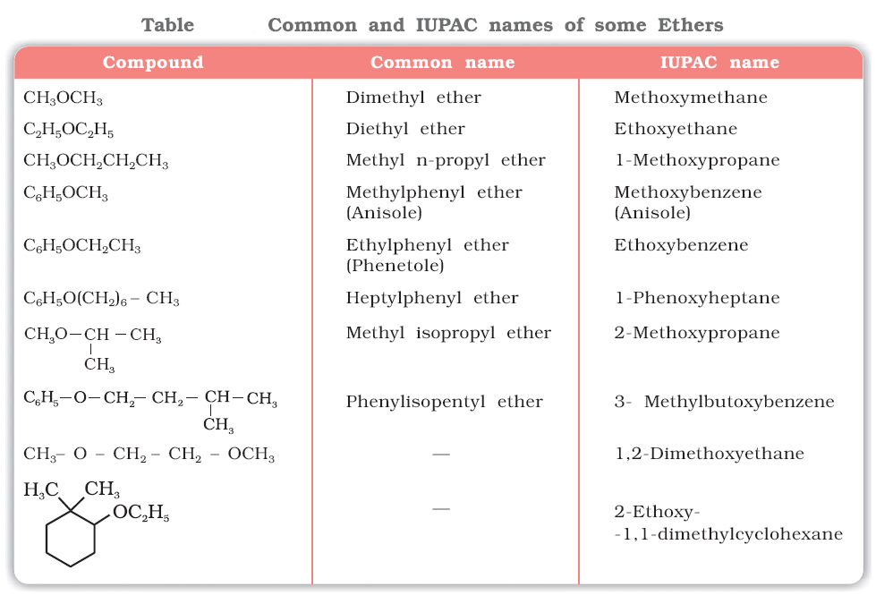

Q.



***Preparation of Alcohols***

***1. From alkenes***

(i) *By acid catalysed hydration*: Alkenes react with water in the presence of acid as catalyst to form alcohols. In case of unsymmetrical alkenes, the addition reaction takes place in accordance with Markovnikov’s rule





**(ii) *By hydroboration–oxidation*:** Diborane (BH3)2 reacts with alkenes to give trialkyl boranes as addition product. This is oxidised to alcohol by hydrogen peroxide in the presence of aqueous sodium hydroxide.



The addition of borane to the double bond takes place in such a manner that the boron atom gets attached to the sp2 carbon carrying greater number of hydrogen atoms. The alcohol so formed looks as if it has been formed by the addition of water to the alkene in a way opposite to the Markovnikov’s rule.

***2. From carbonyl compounds***

(i) *By reduction of aldehydes and ketones*: Aldehydes and ketones are reduced to the corresponding alcohols by addition of hydrogen in the presence of catalysts (catalytic hydrogenation). The usual catalyst is a finely divided metal such as platinum, palladium or nickel. It is also prepared by treating aldehydes and ketones with sodium borohydride (NaBH4) or lithium

aluminium hydride (LiAlH4).



*(ii) By reduction of carboxylic acids and esters*: Carboxylic acids are reduced to primary alcohols in excellent yields by lithium aluminium hydride, a strong reducing agent.



***3. From Grignard reagents***

Alcohols are produced by the reaction of Grignard reagents with aldehydes and ketones. The first step of the reaction is the nucleophilic addition of Grignard reagent to the carbonyl group to form an adduct. Hydrolysis of the adduct yields an alcohol.



The overall reactions using different aldehydes and ketones are as follows:



Q  **(NCERT)**

**Preparation of Phenols**

***1. From haloarenes***



***2. From benzenesulphonic acid***



***3. From diazonium salts***



***4. From cumene***

Phenol is manufactured from the hydrocarbon, cumene. Cumene (isopropylbenzene) is oxidised in the presence of air to cumene hydroperoxide. It is converted to phenol and acetone by treating it with dilute acid.





Q **(NCERT)**

Q



**(NCERT)**

**Physical Properties**

**Boiling Points**

The boiling points of alcohols and phenols increase with increase in the number of carbon atoms (increase in van der Waals forces). In alcohols, the boiling points decrease with increase of branching in carbon chain (because of decrease in van der Waals forces with decrease in surface area).

The –OH group in alcohols and phenols is involved in intermolecular hydrogen bonding.



**Solubility**

Solubility of alcohols and phenols in water is due to their ability to form hydrogen bonds with water molecules as shown. The solubility decreases with increase in size of alkyl/aryl (hydrophobic) groups. Several of the lower molecular mass alcohols are miscible with water in all proportions.

Q



**(NCERT)**

**Chemical Reactions**

Alcohols are versatile compounds. They react both as nucleophiles and electrophiles. The bond between O–H is broken when alcohols react as nucleophiles.



Based on the cleavage of O–H and C–O bonds, the reactions of alcohols and phenols may be divided into two groups:

**(a) Reactions involving cleavage of O–H bond**

***1. Acidity of alcohols and phenols***

*(i) Acidity of alcohols:* The acidic character of alcohols is due to the polar nature of O–H bond. An electron-releasing group (–CH3, –C2H5) increases electron density on oxygen tending to decrease the polarity of O-H bond. This decreases the acid strength. For this reason, the acid strength of alcohols decreases in the following order:



*(ii) Acidity of phenols:* The hydroxyl group, in phenol is directly attached to the *sp2* hybridised carbon of benzene ring which acts as an electron withdrawing group. Due to

this, the charge distribution in phenol molecule, as depicted in its resonance structures, causes the oxygen of –OH group to be positive.



Phenols are stronger acids than alcohols and water.



Due to the higher electronegativity of *sp*2 hybridised carbon of phenol to which –OH is attached, electron density decreases on oxygen. This increases the polarity of O–H bond and results in an increase in ionisation of phenols than that of alcohols.

Alkoxide and phenoxide ions

In alkoxide ion, the negative charge is localised on oxygen while in phenoxide ion, the charge is delocalised. The delocalisation of negative charge (structures I-V) makes phenoxide ion more stable and favours the ionisation of phenol. Although there is also charge delocalisation in phenol, its resonance structures have charge separation due to which the phenol molecule is less stable than phenoxide ion.



In substituted phenols, the presence of electron withdrawing groups such as nitro group, enhances the acidic strength of phenol. This effect is more pronounced when such a group is present at *ortho* and *para* positions. It is due to the effective delocalisation of negative charge in phenoxide ion. On the other

hand, electron releasing groups, such as alkyl groups, in general, do not favour the formation of phenoxide ion resulting in decrease in acid strength. Cresols, for example, are less acidic than phenol.

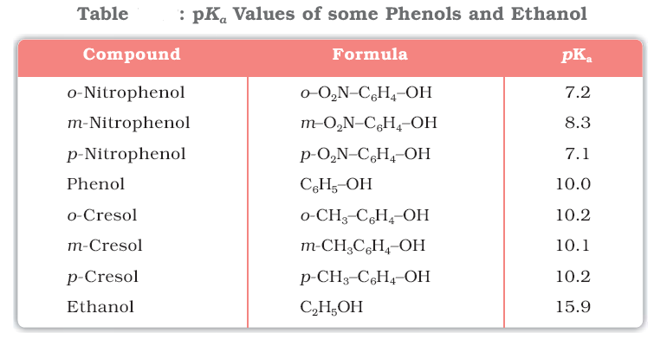

Q.  **(NCERT)**

***2. Esterification***

Alcohols and phenols react with carboxylic acids, acid chlorides and acid anhydrides to form esters.



The introduction of acetyl (CH3CO) group in alcohols or phenols is known as acetylation. Acetylation of salicylic acid produces aspirin.



**(b) Reactions involving cleavage of carbon – oxygen (C–O) bond in alcohols**

***1. Reaction with hydrogen halides:***

***2. Reaction with phosphorus trihalides:***

***3. Dehydration:***

Alcohols undergo dehydration (removal of a molecule of water) to form alkenes on treating with a protic acid e.g., concentrated H2SO4 or H3PO4, or catalysts such as anhydrous zinc chloride or alumina.



The relative ease of dehydration of alcohols follows the following order:





***4. Oxidation:***

Oxidation of alcohols involves the formation of a carbonoxygen double bond with cleavage of an O-H and C-H bonds.



Strong oxidising agents such as acidified potassium permanganate are used for getting carboxylic acids from alcohols directly. CrO3 in anhydrous medium is used as the oxidising agent for the isolation of aldehydes.



A better reagent for oxidation of primary alcohols to aldehydes in good yield is pyridinium chlorochromate (PCC).



Secondary alcohols are oxidised to ketones by chromic anhydride (CrO3).



When the vapours of a primary or a secondary alcohol are passed over heated copper at 573 K, dehydrogenation takes place and an aldehyde or a ketone is formed while tertiary alcohols undergo dehydration.



**(c) Reactions of phenols**

***1. Electrophilic aromatic substitution***

The –OH group attached to the benzene ring activates it towards electrophilic substitution. Also, it directs the incoming group to *ortho* and *para* positions in the ring as these positions become electron rich due to the resonance effect caused by –OH group.

*(i) Nitration:* With dilute nitric acid at low temperature (298 K), phenol yields a mixture of *ortho* and *para* nitrophenols.



*(ii) Halogenation:* On treating phenol with bromine, different reaction products are formed under different experimental conditions.

(a) When the reaction is carried out in solvents of low polarity such as CHCl3 or CS2 and at low temperature, monobromophenols are formed.



(b) When phenol is treated with bromine water, 2,4,6-tribromophenol is formed as white precipitate.



Q.



(NCERT)

***2. Kolbe’s reaction***

Phenoxide ion generated by treating phenol with sodium hydroxide is even more reactive than phenol towards electrophilic aromatic substitution. Hence, it undergoes electrophilic substitution with carbon dioxide, a weak electrophile. *Ortho* hydroxybenzoic acid is formed as the main reaction product.



***3. Reimer-Tiemann reaction***

On treating phenol with chloroform in the presence of sodium hydroxide, a –CHO group is introduced at *ortho* position of benzene ring. This reaction is known as *Reimer - Tiemann reaction*. The intermediate substituted benzal chloride is hydrolysed in the presence of alkali to produce salicylaldehyde.



***4. Reaction of phenol with zinc dust***

Phenol is converted to benzene on heating with zinc dust.



***5. Oxidation***

Oxidation of phenol with chromic acid produces a conjugated diketone known as benzoquinone. In the

presence of air, phenols are slowly oxidised to dark coloured mixtures containing quinones.



Q . (NCERT)



Q. (NCERT)



Q. (NCERT)



Ethers

**Preparation of Ethers**

***1. By dehydration of alcohols***

Alcohols undergo dehydration in the presence of protic acids (H2SO4, H3PO4). The formation of the reaction product, alkene or ether depends on the reaction conditions. For example, ethanol is dehydrated to ethene in the presence of sulphuric acid at 443 K. At 413 K, ethoxyethane is the main product.



The formation of ether is a nucleophilic bimolecular reaction (SN2) involving the attack of alcohol molecule on a protonated alcohol, as indicated below:

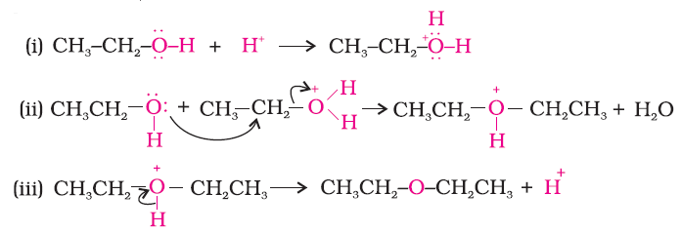

***2. Williamson synthesis***

Ethers containing substituted alkyl groups (secondary or tertiary) may also be prepared by this method. The reaction involves SN2 attack of an alkoxide ion on primary alkyl halide.





Better results are obtained if the alkyl halide is primary. In case of secondary and tertiary alkyl halides, elimination competes over substitution. If a tertiary alkyl halide is used, an alkene is the only reaction product and no ether is formed. For example, the reaction of CH3ONa with (CH3)3C–Br gives exclusively 2-methylpropene.



Q. (NCERT)



**Physical Properties**

The C-O bonds in ethers are polar and thus, ethers have a net dipole moment.

The large difference in boiling points of alcohols and ethers is due to the presence of hydrogen bonding in alcohols.

The miscibility of ethers with water resembles those of alcohols of the same molecular mass. This is due to the fact that just like alcohols, oxygen of ether can also form hydrogen bonds with water

molecule.

**Chemical Reactions**

***1. Cleavage of C–O bond in ethers***

Ethers are the least reactive of the functional groups. The cleavage of C-O bond in ethers takes place under drastic conditions with excess of hydrogen halides.

Alkyl aryl ethers are cleaved at the alkyl-oxygen bond due to the more stable aryl-oxygen bond. The reaction yields phenol and alkyl halide.





However, when one of the alkyl group is a tertiary group, the halide formed is a tertiary halide. 





***2. Electrophilic substitution***

The alkoxy group (-OR) is *ortho*, *para* directing and activates the aromatic ring towards electrophilic substitution in the same way as in phenol.



(i) *Halogenation*:



(ii) *Friedel-Crafts reaction*:



(iii) *Nitration*:



Q. Write the reactions of Williamson synthesis of 2-ethoxy-3-methylpentane starting from ethanol and 3-methylpentan-2-ol. **(NCERT)**

Q.



**(NCERT)**

Q.  **(NCERT)**



# NCERT Exercise

Q 1. 

Q.



**Q.4** Explain why propanol has higher boiling point than that of the hydrocarbon, butane?

**Q.5** Alcohols are comparatively more soluble in water than hydrocarbons of comparable molecular masses. Explain this fact.

**Q.6** What is meant by hydroboration-oxidation reaction? Illustrate it with an example.

**Q.7** Give the structures and IUPAC names of monohydric phenols of molecular formula, C7H8O.

**Q.8** While separating a mixture of *ortho* and *para* nitrophenols by steam distillation, name the isomer which will be steam volatile. Give reason.

**Q.9** Give the equations of reactions for the preparation of phenol from cumene.

**Q.10** Write chemical reaction for the preparation of phenol from chlorobenzene.

**Q.11** Write the mechanism of hydration of ethene to yield ethanol.

**Q.12** You are given benzene, conc. H2SO4 and NaOH. Write the equations for the preparation of phenol using these reagents.

**Q.13** Show how will you synthesise:

(i) 1-phenylethanol from a suitable alkene.

(ii) cyclohexylmethanol using an alkyl halide by an SN2 reaction.

(iii) pentan-1-ol using a suitable alkyl halide?

**Q.14** Give two reactions that show the acidic nature of phenol. Compare acidity of phenol with that of ethanol.

**Q.15** Explain why is *ortho* nitrophenol more acidic than *ortho* methoxyphenol ?

**Q.16** Explain how does the –OH group attached to a carbon of benzene ring activate it towards electrophilic substitution?

**Q.17** Give equations of the following reactions:

(i) Oxidation of propan-1-ol with alkaline KMnO4 solution.

(ii) Bromine in CS2 with phenol.

(iii) Dilute HNO3 with phenol.

(iv) Treating phenol wih chloroform in presence of aqueous NaOH.

**Q.18** Explain the following with an example.

(i) Kolbe’s reaction.

(ii) Reimer-Tiemann reaction.

(iii) Williamson ether synthesis.

(iv) Unsymmetrical ether.

**Q.19** Write the mechanism of acid dehydration of ethanol to yield ethene.

**Q.20** How are the following conversions carried out?

(i) Propene → Propan-2-ol.

(ii) Benzyl chloride → Benzyl alcohol.

(iii) Ethyl magnesium chloride → Propan-1-ol.

(iv) Methyl magnesium bromide → 2-Methylpropan-2-ol.

**Q.21** Name the reagents used in the following reactions:

(i) Oxidation of a primary alcohol to carboxylic acid.

(ii) Oxidation of a primary alcohol to aldehyde.

(iii) Bromination of phenol to 2,4,6-tribromophenol.

(iv) Benzyl alcohol to benzoic acid.

(v) Dehydration of propan-2-ol to propene.

(vi) Butan-2-one to butan-2-ol.

**Q.22** Give reason for the higher boiling point of ethanol in comparison to methoxymethane.

Q



**Q.24** Write the names of reagents and equations for the preparation of the following ethers by Williamson’s synthesis:

(i) 1-Propoxypropane (ii) Ethoxybenzene (iii) 2-Methoxy-2-methylpropane (iv) 1-Methoxyethane

**Q.25** Illustrate with examples the limitations of Williamson synthesis for the preparation of certain types of ethers.

**Q.26** How is 1-propoxypropane synthesised from propan-1-ol? Write mechanism of this reaction.

**Q.27** Preparation of ethers by acid dehydration of secondary or tertiary alcohols is not a suitable method. Give reason.

**Q.28** Write the equation of the reaction of hydrogen iodide with:

(i) 1-propoxypropane (ii) methoxybenzene and (iii) benzyl ethyl ether.

**Q.29** Explain the fact that in aryl alkyl ethers (i) the alkoxy group activates the benzene ring towards electrophilic substitution and (ii) it directs the incoming substituents to ortho and para positions in benzene ring.

**Q.30** Write the mechanism of the reaction of HI with methoxymethane.

**Q.31** Write equations of the following reactions:

(i) Friedel-Crafts reaction – alkylation of anisole.

(ii) Nitration of anisole.

(iii) Bromination of anisole in ethanoic acid medium.

(iv) Friedel-Craft’s acetylation of anisole.

**Q.32** Show how would you synthesise the following alcohols from appropriate alkenes?



Q



## Acyl Groups

In aldehydes, the carbonyl group is bonded to a carbon and hydrogen while in the ketones, it is bonded to two carbon atoms. The carbonyl compounds in which carbonyl group is bonded to oxygen are known as carboxylic acids, and their derivatives (e.g. esters, anhydrides) while in compounds where carbon is attached to nitrogen and to halogens are called amides and acyl halides respectively.





Nomenclature and Structure of Carbonyl Group

Aldehydes and ketones are the simplest and most important carbonyl compounds.

***(a) Common names***

Aldehydes and ketones are often called by their common names instead of IUPAC names. The common names of most aldehydes are derived from the common names of the corresponding carboxylic acids by replacing the ending –*ic* of acid with aldehyde.



The common names of ketones are derived by naming two alkyl or aryl groups bonded to the carbonyl group.



***(b) IUPAC names***

The IUPAC names of open chain aliphatic aldehydes and ketones are derived from the names of the corresponding alkanes by replacing the ending –*e* with –*al* and –*one* respectively. In case of aldehydes the longest carbon chain is numbered starting from the carbon of the aldehyde group while in case of ketones the numbering begins from the end nearer to the carbonyl group.



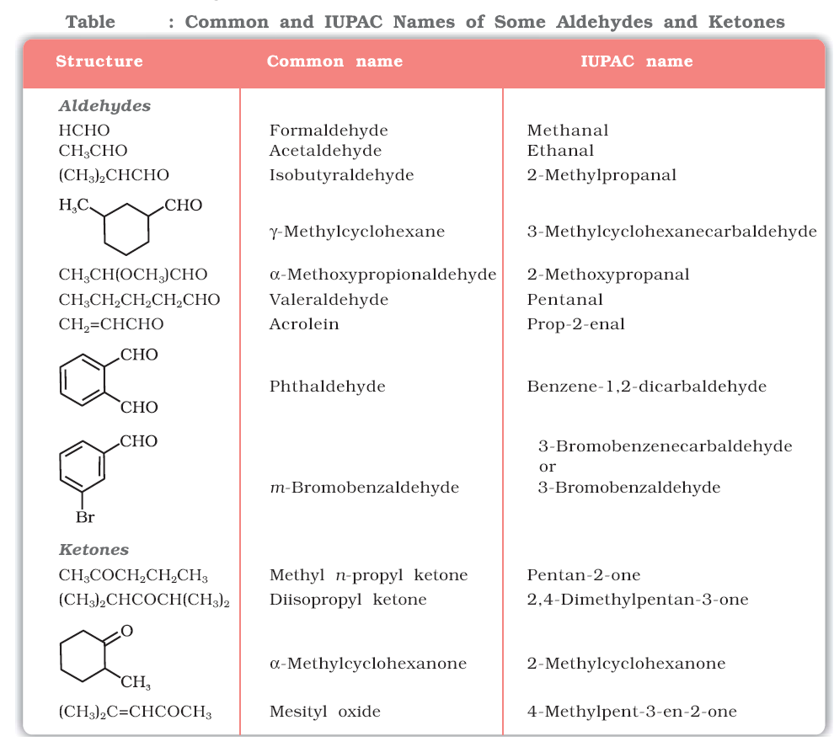

**Structure of the Carbonyl Group**

The carbonyl carbon atom is *sp2*-hybridised and forms three sigma (σ) bonds. The fourth valence electron of carbon remains in its *p*-orbital and forms a π-bond with oxygen by overlap with *p*-orbital of an oxygen.



Q.



Preparation of Aldehydes and Ketones

***1. By oxidation of alcohols***

***2. By dehydrogenation of alcohols***

***3. From hydrocarbons***

(*i*) *By ozonolysis of alkenes:* As we know, ozonolysis of alkenes followed by reaction with zinc dust and water gives aldehydes, ketones or a mixture of both depending on the substitution pattern of the alkene.

(*ii*) *By hydration of alkynes:* Addition of water to ethyne in the presence of H2SO4 and HgSO4 gives acetaldehyde. All other alkynes give ketones in this reaction .

**Preparation of Aldehydes**

***1. From acyl chloride (acid chloride)***

Acyl chloride (acid chloride) is hydrogenated over catalyst, palladium on barium sulphate. This reaction is called **Rosenmund reduction**.



***2. From nitriles and esters***

Nitriles are reduced to corresponding imine with stannous chloride in the presence of hydrochloric acid, which on hydrolysis give corresponding aldehyde.



This reaction is called **Stephen** reaction**.**

Alternatively, nitriles are selectively reduced by diisobutylaluminium hydride, (DIBAL-H) to imines followed by hydrolysis to aldehydes:



***3. From hydrocarbons***

Aromatic aldehydes (benzaldehyde and its derivatives) are prepared from aromatic hydrocarbons by the following methods:

*(i) By oxidation of methylbenzene*

Strong oxidising agents oxidise toluene and its derivatives to benzoic acids. However, it is possible to stop the oxidation at the aldehyde stage with suitable reagents that convert the methyl group to an intermediate that is difficult to oxidise further.

(a) Use of chromyl chloride (CrO2Cl2): Chromyl chloride oxidizes methyl group to a chromium complex, which on hydrolysis gives corresponding benzaldehyde.



This reaction is called **Etard reaction**.

(b) Use of chromic oxide (CrO3): Toluene or substituted toluene is converted to benzylidene diacetate on treating with chromic oxide in acetic anhydride. The benzylidene diacetate can be hydrolysed to corresponding benzaldehyde with aqueous acid.



*(ii) By side chain chlorination followed by hydrolysis*

Side chain chlorination of toluene gives benzal chloride, which on hydrolysis gives benzaldehyde. This is a commercial method of manufacture of benzaldehyde.



*(iii) By Gatterman – Koch reaction*

When benzene or its derivative is treated with carbon monoxide and hydrogen chloride in the presence of anhydrous aluminium chloride or cuprous chloride, it gives benzaldehyde or substituted benzaldehyde.



This reaction is known as **Gatterman-Koch** reaction.

**Preparation of Ketones**

***1. From acyl chlorides***

Treatment of acyl chlorides with dialkylcadmium, prepared by the reaction of cadmium chloride with Grignard reagent, gives ketones.



***2. From nitriles***

Treating a nitrile with Grignard reagent followed by hydrolysis yields a ketone.



***3. From benzene or substituted benzenes***

When benzene or substituted benzene is treated with acid chloride in the presence of anhydrous aluminium chloride, it affords the corresponding ketone. This reaction is known as **Friedel-Crafts acylation reaction**.



***Q.***



***Q.***

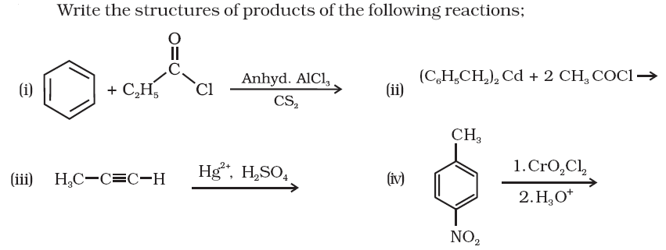

Physical Properties

Methanal is a gas at room temperature. Ethanal is a volatile liquid. Other aldehydes and ketones are liquid or solid at room temperature. The boiling points of aldehydes and ketones are higher than hydrocarbons and ethers of comparable molecular masses. It is due to weak molecular association in aldehydes and ketones arising out of the dipole-dipole interactions. Also, their boiling points are lower than those of alcohols of similar molecular masses due to absence of intermolecular hydrogen bonding.

All aldehydes and ketones are fairly soluble in organic solvents like benzene, ether, methanol, chloroform, etc. The lower aldehydes have sharp pungent odours. As the size of the molecule increases, the odour becomes less pungent and more fragrant.

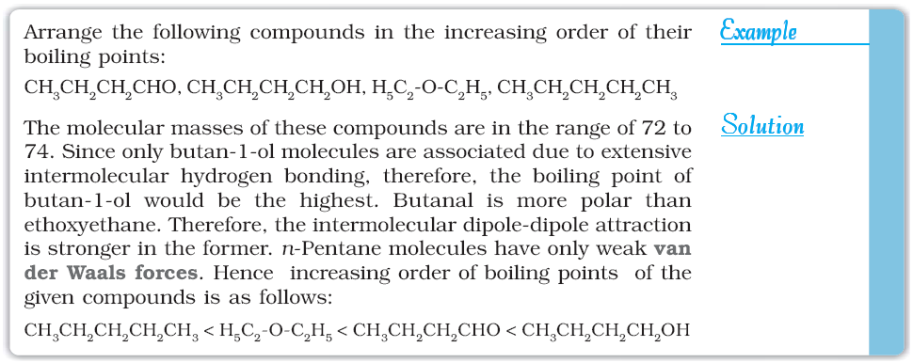

Q.



Chemical Reactions

1. Nucleophilic addition reactions

*(i) Mechanism of nucleophilic addition reactions*

A nucleophile attacks the electrophilic carbon atom of the polar carbonyl group from a direction approximately perpendicular to the plane of *sp2* hybridised orbitals of carbonyl carbon .The hybridisation of carbon changes from *sp2* to *sp3* in this process, and a tetrahedral alkoxide intermediate is produced.

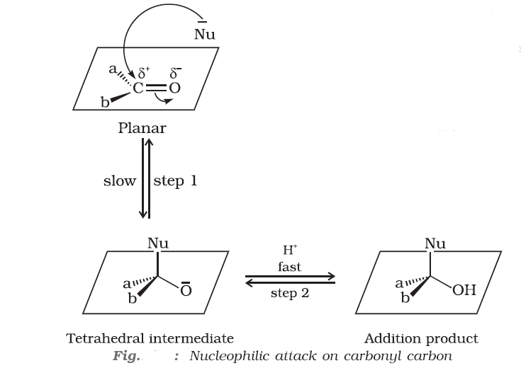

*(ii) Reactivity*

Aldehydes are generally more reactive than ketones in nucleophilic addition reactions due to steric and electronic reasons. Sterically, the presence of two relatively large substituents in ketones hinders the approach of nucleophile to carbonyl carbon than in aldehydes having only one such substituent. Electronically, aldehydes are more reactive than ketones because two alkyl groups reduce the electrophilicity of the carbonyl more effectively than in former.

Q. Would you expect benzaldehyde to be more reactive or less reactive in nucleophilic addition reactions than propanal? Explain your answer.

*(iii) Some important examples of nucleophilic addition and nucleophilic addition-elimination reactions:*

(a) *Addition of hydrogen cyanide (HCN)*:



(b) *Addition of sodium hydrogensulphite:*



(d) *Addition of alcohols:*



(e) *Addition of ammonia and its derivatives*:



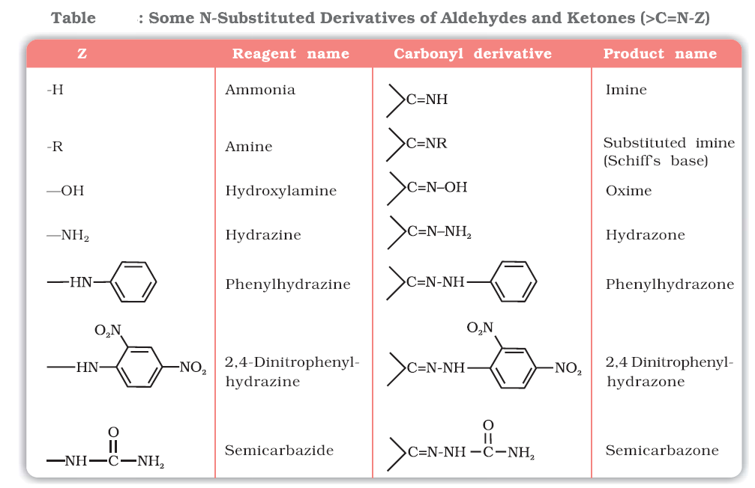

***2. Reduction***

*(i) Reduction to alcohols:*

Aldehydes and ketones are reduced to primary and secondary alcohols respectively by sodium borohydride (NaBH4) or lithium aluminium hydride (LiAlH4) as well as by catalytic hydrogenation.

(*ii*) *Reduction to hydrocarbons:*

The carbonyl group of aldehydes and ketones is reduced to CH2 group on treatment with zincamalgam

and concentrated hydrochloric acid[**Clemmensen reduction**] or with hydrazine followed by heating with sodium or potassium hydroxide in high boiling solvent such as ethylene glycol (**Wolff-Kishner reduction**).



***3. Oxidation***

Aldehydes are easily oxidised to carboxylic acids on treatment with common oxidising agents like nitric acid, potassium permanganate, potassium dichromate, etc. Even mild oxidising agents, mainly Tollens’ reagent and Fehlings’ reagent also oxidise aldehydes.



Ketones are generally oxidised under vigorous conditions, i.e., strong oxidising agents and at elevated temperatures. Their oxidation involves carbon-carbon bond cleavage to afford a mixture of carboxylic

acids having lesser number of carbon atoms than the parent ketone.



The mild oxidising agents given below are used to distinguish aldehydes from ketones:

*(i) Tollens’ test:*

On warming an aldehyde with freshly prepared ammoniacal silver nitrate solution (Tollens’ reagent), a bright silver mirror is produced due to the formation of silver metal. The aldehydes are oxidised to corresponding carboxylate anion.



*(ii) Fehling’s test:*

On heating an aldehyde with Fehling’s reagent, a reddish brown precipitate is obtained. Aldehydes are oxidised to corresponding carboxylate anion. Aromatic aldehydes do not respond to this test.



*(iii) Oxidation of methyl ketones by haloform reaction*:



Q. An organic compound (A) with molecular formula C8H8O forms an orange-red precipitate with 2,4-DNP reagent and gives yellow precipitate on heating with iodine in the presence of sodium hydroxide. It neither reduces Tollens’ or Fehlings’ reagent, nor does it decolourise bromine water or Baeyer’s reagent. On drastic oxidation with chromic acid, it gives a carboxylic acid (B) having molecular formula C7H6O2. Identify the compounds (A) and (B) and explain the reactions involved.

***4. Reactions due to a-hydrogen***

The acidity of α-hydrogen atoms of carbonyl compounds is due to the strong electron withdrawing effect of the carbonyl group and resonance stabilisation of the conjugate base.



*(i) Aldol condensation:* Aldehydes and ketones having at least one α-hydrogen undergo a reaction in the presence of dilute alkali as catalyst to form β-hydroxy aldehydes (aldol) or β-hydroxy ketones (ketol), respectively. This is known as **Aldol reaction.**



***5. Other reactions***

(*i*) *Cannizzaro reaction:*

Aldehydes which do not have an α-hydrogen atom, undergo self oxidation and reduction (disproportionation) reaction on treatment with concentrated alkali. In this reaction, one molecule of the aldehyde is reduced to alcohol while another is oxidised to carboxylic acid salt.



(*ii*) *Electrophilic substitution reaction*:

Aromatic aldehydes and ketones undergo electrophilic substitution at the ring in which the carbonyl group acts as a deactivating and *meta*-directing group.



Q.

Q.



Nomenclature and Structure of Carboxyl Group

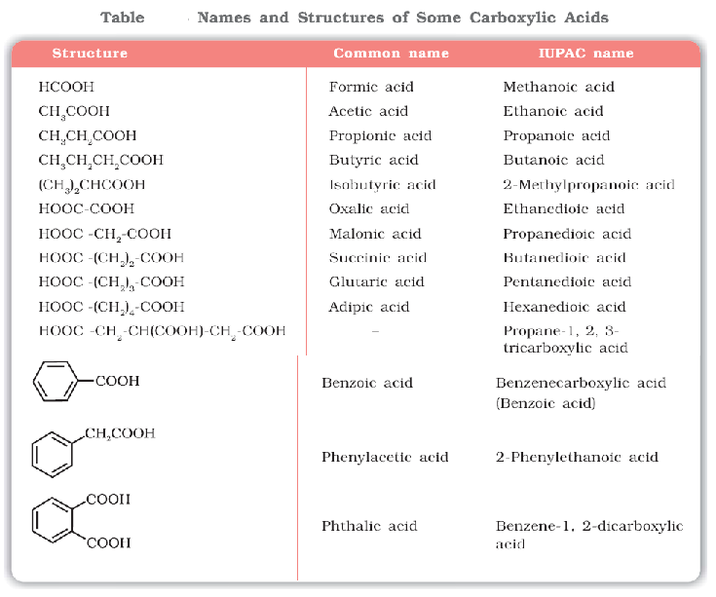

Q.



Methods of Preparation of Carboxylic Acids

***1. From primary alcohols and aldehydes***



***2. From alkylbenzenes***

Aromatic carboxylic acids can be prepared by vigorous oxidation of alkyl benzenes with chromic acid or acidic or alkaline potassium permanganate. The entire side chain is oxidised to the carboxyl group irrespective of length of the side chain. Primary and secondary alkyl groups are oxidised in this manner while tertiary group is not affected. Suitably substituted alkenes are also oxidised to carboxylic acids with these oxidising reagents.



***3. From nitriles and amides***

Nitriles are hydrolysed to amides and then to acids in the presence of H+ or OH− as catalyst. Mild reaction conditions are used to stop the reaction at the amide stage.



***4. From Grignard reagents***

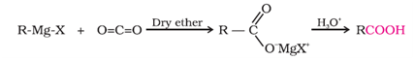

***5. From acyl halides and anhydrides***



***6. From esters***

Acidic hydrolysis of esters gives directly carboxylic acids while basic hydrolysis gives carboxylates, which on acidification give corresponding carboxylic acids.



Q.



Q.



Physical Properties

Aliphatic carboxylic acids upto nine carbon atoms are colourless liquids at room temperature with unpleasant odours. The higher acids are wax like solids and are practically odourless due to their low volatility. Carboxylic acids are higher boiling liquids than aldehydes, ketones and even alcohols of comparable molecular masses. This is due to more extensive association of carboxylic acid molecules through intermolecular hydrogen bonding. The hydrogen bonds are not broken completely even in the vapour phase. In fact, most carboxylic acids exist as dimer in the vapour phase or in the aprotic solvents.

Simple aliphatic carboxylic acids having upto four carbon atoms are miscible in water due to the formation of hydrogen bonds with water. The solubility decreases with increasing number of carbon atoms. Higher carboxylic acids are practically insoluble in water due to the increased hydrophobic interaction of hydrocarbon part. Benzoic acid, the simplest aromatic carboxylic acid is nearly insoluble in cold water. Carboxylic acids are also soluble in less polar organic solvents like benzene, ether, alcohol, chloroform, etc.



Chemical Reactions

**Reactions Involving Cleavage of O–H Bond**

***Acidity***

*Reactions with metals and alkalies*



Carboxylic acids are weaker than mineral acids, but they are stronger acids than alcohols and many simple phenols (p*Ka* is ~16 for ethanol and 10 for phenol). In fact, carboxylic acids are amongst the most acidic organic compounds.

*Effect of substituents on the acidity of carboxylic acids:*

Electron withdrawing groups increase the acidity of carboxylic acids by stabilising the conjugate base through delocalisation of the negative charge by inductive and/or resonance effects. Conversely, electron donating groups decrease the acidity by destabilising the conjugate base.





**Reactions Involving Cleavage of C–OH Bond**

***1. Formation of anhydride***



***2. Esterification***





***3. Reactions with PCl5, PCl3 and SOCl2***



***4. Reaction with ammonia***



**Reactions Involving –COOH Group**

***1. Reduction***



***2. Decarboxylation***

Carboxylic acids lose carbon dioxide to form hydrocarbons when their sodium salts are heated with sodalime (NaOH and CaO in the ratio of 3 : 1). The reaction is known as decarboxylation.



Alkali metal salts of carboxylic acids also undergo decarboxylation on electrolysis of their aqueous solutions and form hydrocarbons having twice the number of carbon atoms present in the alkyl group of the acid. The reaction is known as **Kolbe electrolysis.**

**Substitution Reactions in the Hydrocarbon Part**

***1. Halogenation***

Carboxylic acids having an α-hydrogen are halogenated at the α-position on treatment with chlorine or bromine in the presence of small amount of red phosphorus to give α-halocarboxylic acids. The reaction is known as **Hell-Volhard-Zelinsky reaction.**



***2. Ring substitution***

Aromatic carboxylic acids undergo electrophilic substitution reactions in which the carboxyl group acts as a deactivating and meta-directing group. They however, do not undergo **Friedel-Crafts reaction** (because the carboxyl group is deactivating and the catalyst aluminium chloride (Lewis acid) gets bonded to the carboxyl group).



Q.



NCERT Exercises

Q2.



Q3.



Q4.



Q5.



Q6.



Q7.



Q8.



Q9.



Q10.





Q11.

Q12.



Q13. Give simple chemical tests to distinguish between the following pairs of compounds.

(i) Propanal and Propanone (ii) Acetophenone and Benzophenone

(iii) Phenol and Benzoic acid (iv) Benzoic acid and Ethyl benzoate

(v) Pentan-2-one and Pentan-3-one (vi) Benzaldehyde and Acetophenone

(vii) Ethanal and Propanal

Q14.



Q15.



Q17. Complete each synthesis by giving missing starting material, reagent or products



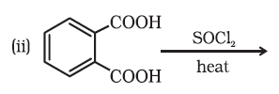



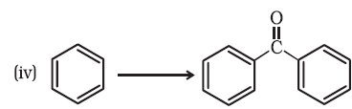















Q18.



Q19.





Q20.

## Amines

Amines constitute an important class of organic compounds derived by replacing one or more hydrogen atoms of ammonia molecule by alkyl/aryl group(s).

**AMINES**

Amines can be considered as derivatives of ammonia, obtained by replacement of one, two or all the three hydrogen atoms by alkyl and/or aryl groups. For example:



Structure of Amines

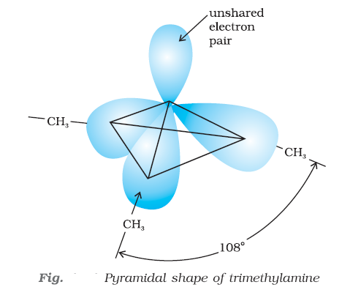

Classification



# Test Series

# Test (Some Basic concepts of chemistry )

**Time Allowed : 1 hour ________________________ Maximum Marks : 29**

Please read the instructions carefully. You will be alloted 5 minutes specifically for this purpose.

**Instructions**

**A. General**

1. Blank papers, clipboards, log tables, slide rules, calculators, cellular phones, pagers, and electronic gadgets in any form are not allowed.

2. Do not break the seals of the question-paper booklet before instructed to do so by the invigilators.

**B. Question paper format and Marking Scheme :**

1. This question paper consists of 12 questions carrying a total of 26 Marks, Questions 1 to 3 carry 1 mark each, Questions 4 to 8 carry 2 marks each , Questions 9 to 10 carry 3 marks each and questions 11 to 12 carry five marks each.

**Q1 :** Calculate molecular mass of glucose (C6H12O6) molecule. 1 Marks

**Q2 :** Classify following as pure substances and mixtures – Air, glucose, gold,sodium and milk.

1 Marks

**Q3 :** State Avogadro’s law. 1 Marks

**Q4 :** A solution is prepared by adding 2 g of a substance A to 18 g of water. Calculate the mass per cent of the solute. 2 Marks

**Q5 :** Calculate the molarity of NaOH in the solution prepared by dissolving its 4 g in enough water to form 250 mL of the solution. 2 Marks

**Q6 :** Calculate the amount of water (g) produced by the combustion of 16 g of methane.

2 Marks

**Q7 :** Write the seven fundamental quantities & their units. 2 Marks

**Q8 :** What is the difference between mass & weight? How is mass measured in laboratory?

2 Marks

**Q9:** A compound contains 4.07 % hydrogen, 24.27 % carbon and 71.65 % chlorine. Its molar mass is 98.96 g. What are its empirical and molecular formulas ? 3 Marks

**Q10 :** How many moles of methane are required to produce 22 g CO2 (g) after combustion?

3 Marks

**Q11 :** 50.0 kg of N2 (g) and 10.0 kg of H2 (g) are mixed to produce NH3 (g). Calculate the

NH3 (g) formed. Identify the limiting reagent in the production of NH3 in this situation. 5 Marks

**Q12 :** The density of 3 M solution of NaCl is 1.25 g mL–1. Calculate molality of the solution. 5 Marks

# Test (Structure of Atom )

**Time Allowed : 1 hour ________________________ Maximum Marks : 31**

Please read the instructions carefully. You will be alloted 5 minutes specifically for this purpose.

**Instructions**

**A. General**

1. Blank papers, clipboards, log tables, slide rules, calculators, cellular phones, pagers, and electronic gadgets in any form are not allowed.

2. Do not break the seals of the question-paper booklet before instructed to do so by the invigilators.

**B. Question paper format and Marking Scheme :**

1. This question paper consists of 9 questions carrying a total of 31 Marks, Questions 1 to 3 carry 1 mark each, Questions 4 to 6 carry 2 marks each , Questions 7 to 10 carry 3 marks each and questions 11 to 12 carry five marks each.

**Q1 :** Define photoelectric effect. 1 Marks

**Q2 :** Define black body radiation. 1 Marks

**Q3** : Give the range of wavelength of the visible spectrum. 1 Marks

**Q4 :** Calculate the wavelength corresponding to a frequency of 98.8MHz. 2 Marks

**Q5** : What is the e/m ratio of an electron? 2 Marks

**Q6 :** Why Rutherford’s model could not explain the stability of an atom? 2 Marks

**Q7 :** Which experiment led to the discovery of electrons and how? 3 Marks

**Q8 :** Electromagnetic radiation of wavelength 242 nm is just sufficient to ionise the sodium atom. Calculate the ionisation energy of sodium in kJ mol–1 3 Marks

**Q9 :** What is the number of photons of light with a wavelength of 4000 pm that provide 1J of energy? 3 Marks

**Q10 :** A 25 watt bulb emits monochromatic yellow light of wavelength of 0.57μm. Calculate the rate of emission of quanta per second. 3 Marks

**Q11 :** What transition in the hydrogen spectrum would have the same wavelength as the Balmer transition, n = 4 to n = 2 of He+ spectrum? 5 Marks

**Q12 :** An ion with mass number 37 possesses one unit of negative charge. If the ion conatins 11.1% more neutrons than the electrons, find the symbol of the ion. 5 Marks

# Test (Classification of Elements and Periodicity in Properties)

**Time Allowed : 1 hour ________________________ Maximum Marks : 20**

Please read the instructions carefully. You will be alloted 5 minutes specifically for this purpose.

**Instructions**

**A. General**

1. Blank papers, clipboards, log tables, slide rules, calculators, cellular phones, pagers, and electronic gadgets in any form are not allowed.

2. Do not break the seals of the question-paper booklet before instructed to do so by the invigilators.

**B. Question paper format and Marking Scheme :**

1. This question paper consists of 9 questions carrying a total of 31 Marks, Questions 1 to 2 carry 1 mark each, Questions 3 to 4 carry 2 marks each , Questions 5 to 7 carry 3 marks each and question 8 carries five marks.

**Q1 :** How does atomic size change in a group? 1 Marks

**Q2 :** What is the basic theme of organisation in the periodic table? 1 Marks

**Q3 :** Consider the following species : N 3– , O2–, F– , Na+ , Mg2+ and Al3+

(a) What is common in them?

(b) Arrange them in the order of increasing ionic radii. 2 Marks

**Q4 :** (a) What is an amphoteric oxide?

(b) Define a neutral oxide. 2 Marks

**Q5 :** (a)Why do Na and K have similar properties?

(b) Why does lithium form covalent bond unlike other alkali which forms ionic bond? 3 Marks

**Q6 :** Na+ has higher value of ionization enthalpy than Ne, though both have same electronic configuration. 3 Marks

**Q7 :** Among the second period elements the actual ionization enthalpies are in the order

Li < B < Be < C < O < N < F < Ne. Explain why

1. Be has higher ∆i H than B
2. O has lower ∆i H than N and F? 3 Marks

**Q8:** (i) Arrange the following elements in the increasing order of metallic character :

Si, Be, Mg, Na, P

(ii) Among the elements

B, Al, C and Si

(a) Which has the highest first ionization enthalpy?

(b) Which has the largest atomic radius? 5 Marks